– Biologics Portal Runbook

**Version**: 1.0

**Last Updated**: June 06, 2022

Table of Contents

1. Background 3

1.1 Application Overview 3

1.2 Application Team Details 3

2. Prerequisites 4

3. Directory 5

3.1 Groups 5

3.2 Profile Editor 5

4. Applications 21

4.1 Application 21

5. Security 24

5.1 Authenticators 24

5.2 Authentication policies 30

5.3 Identity Providers 30

5.4 API 35

6. Functional Diagram & Flow 43

6.1 Flow Diagram 43

6.2 Process Flows 43

7. Logging 45

7.1 System Logs 45

8. Test Login 46

9. Common Error/Issues: 52

# Background

This runbook has been created to use as a reference guide to complete the application integration in higher environment.

## Application Overview

Biologics Commercial portal is built for drugs manufacturers from Biologics, who are McKesson clients. It’s a web bases B2B application. The portal is accessed by external and internal users where external users are all Biologics clients and internal users are McKesson Employees.

.

## Application Team Details

|  |  |  |
| --- | --- | --- |
| **Role** | **Name** | **Email** |
| BU Owner | MPS | NA |
| Business Owner |  |  |
| Product/Application Owner |  |  |
| Technical POC |  |  |
| Application DL | NA | NA |
| 3rd Party technical Contact | NA | NA |

# Prerequisites

In order to proceed through this runbook, the following activities need to be completed and information/access acquired in order to have a successful implementation through the runbook.

|  |  |
| --- | --- |
| **Activity** | **Reason** |
| Super Admin  credentials | Org2Org Admin group push should be enabled and integrated to B2E for a centralized access control of tenant administration. Super admin requires to do all Org2Org setup. |
| Okta API Token | API tokens are generated with the permissions of the user that created the token. On the Okta B2B tenant, super admin required to create API token to use for Org2Org provisioning |
| Biologics Application Endpoints | Callback/Redirect URL and sign-out URL is required to integrate with Okta |

Fill out the following based on environment deployment:

|  |  |  |
| --- | --- | --- |
| **Application** | **UAT** | **Prod** |
| Okta | [mckb2bbiologics-qa.oktapreview.com](https://urldefense.com/v3/__http:/mckb2bbiologics-qa.oktapreview.com__;!!KMayzP4JbQ!cVHtDRMaRsaIF66ms_wpsRVL4AW32YeiaUVnPE5MNUKDtNP_QNwgQ4Gg7cKn2C8t8xxn5A-afwibO-pZYoaFhA$) | [mckb2bbiologics.okta.com](https://urldefense.com/v3/__http:/mckb2bbiologics.okta.com__;!!KMayzP4JbQ!cVHtDRMaRsaIF66ms_wpsRVL4AW32YeiaUVnPE5MNUKDtNP_QNwgQ4Gg7cKn2C8t8xxn5A-afwibO-oUn2lF7w$) |
| Biologics Portal | https://biologics-portal-manufacturer-ui.dev.aks.west.us.mckesson.com |  |

# Directory

## Groups

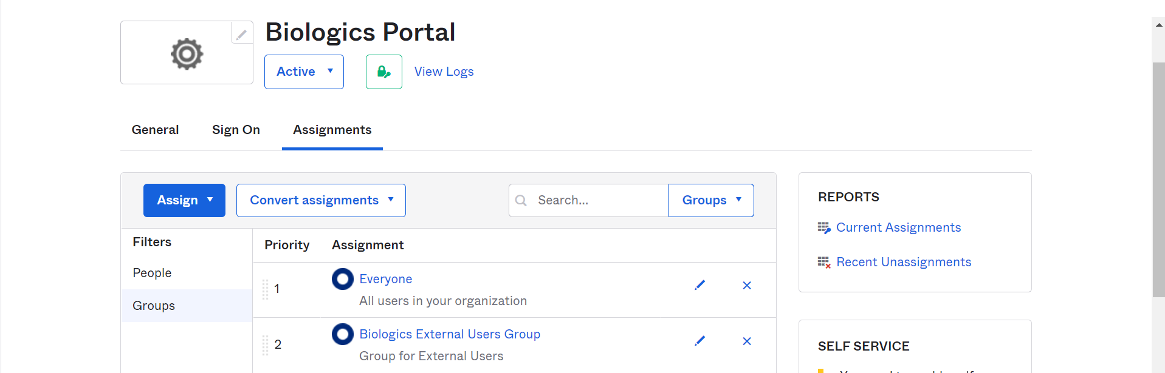

## Profile Editor

### User(Default)

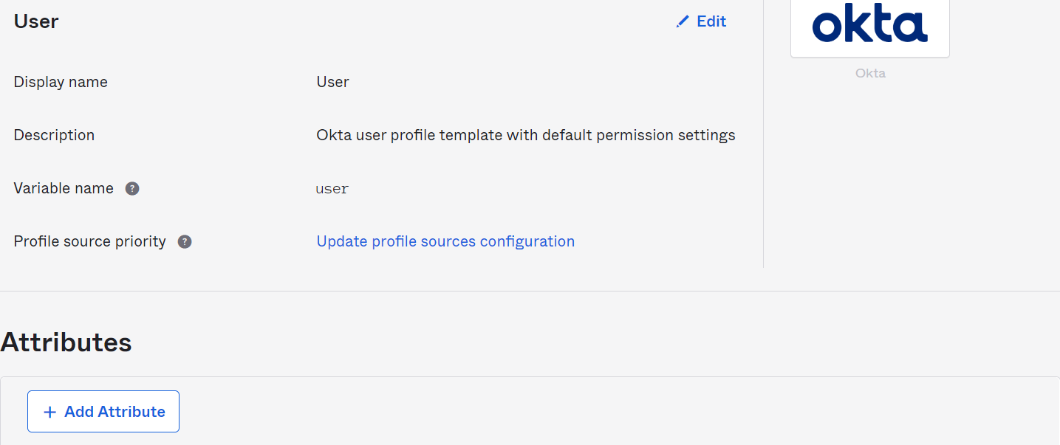

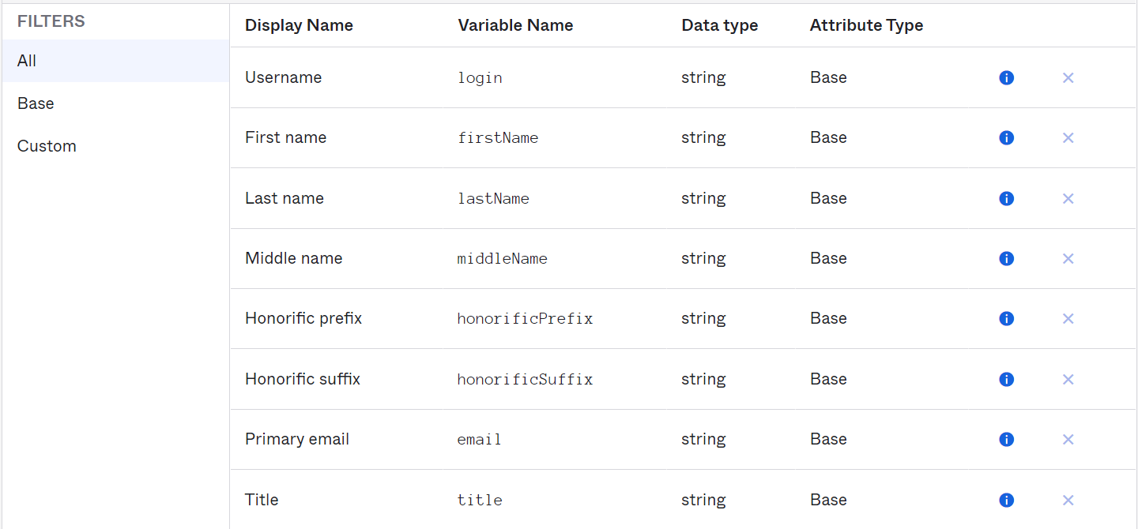

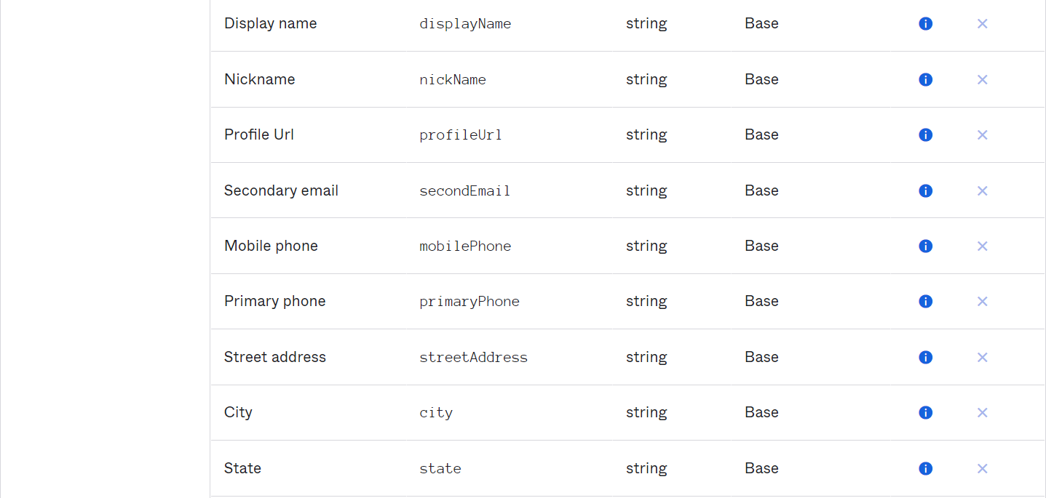

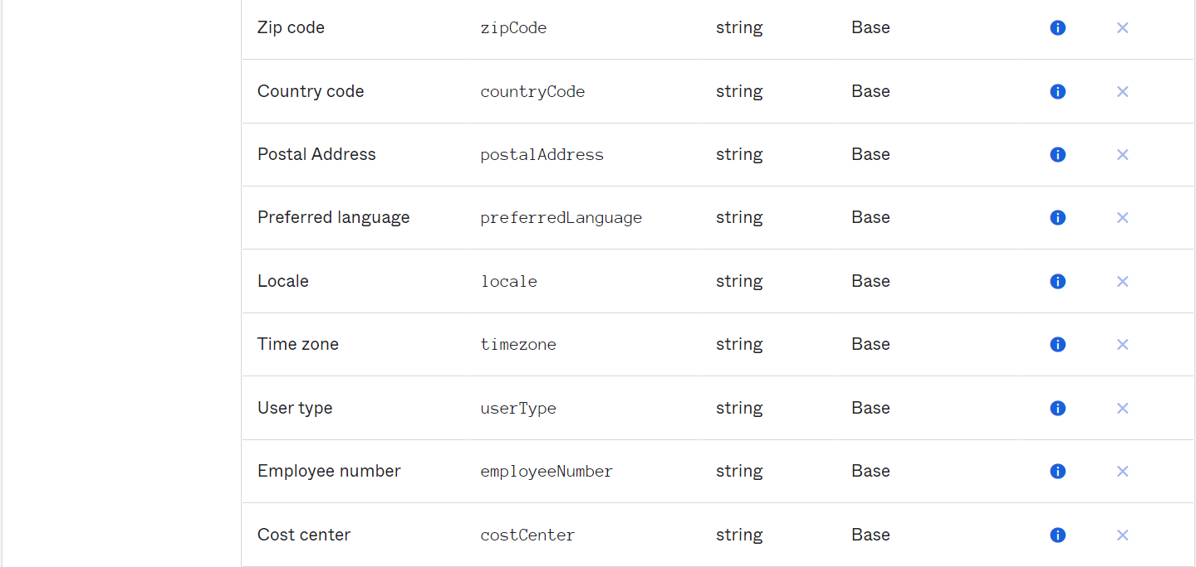

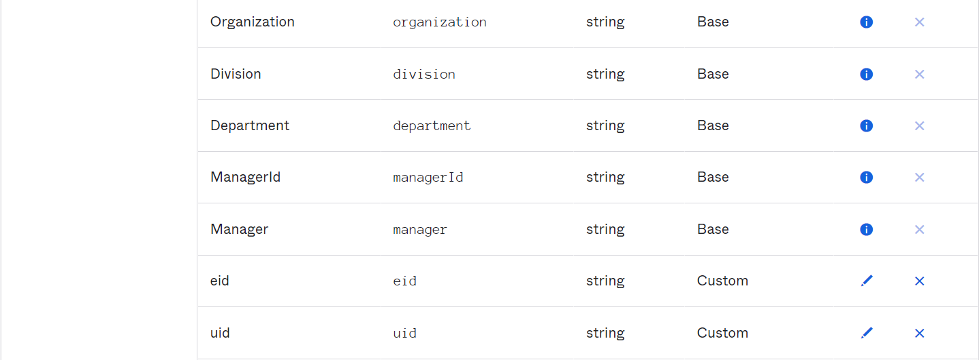

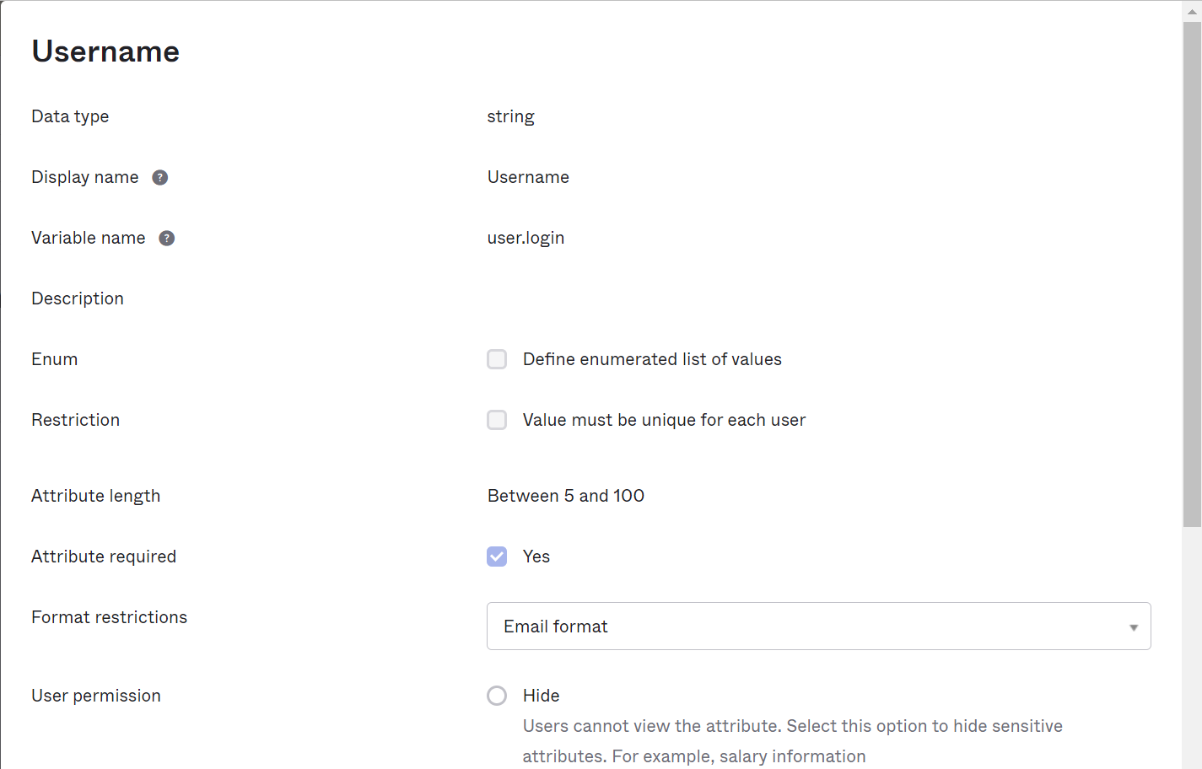

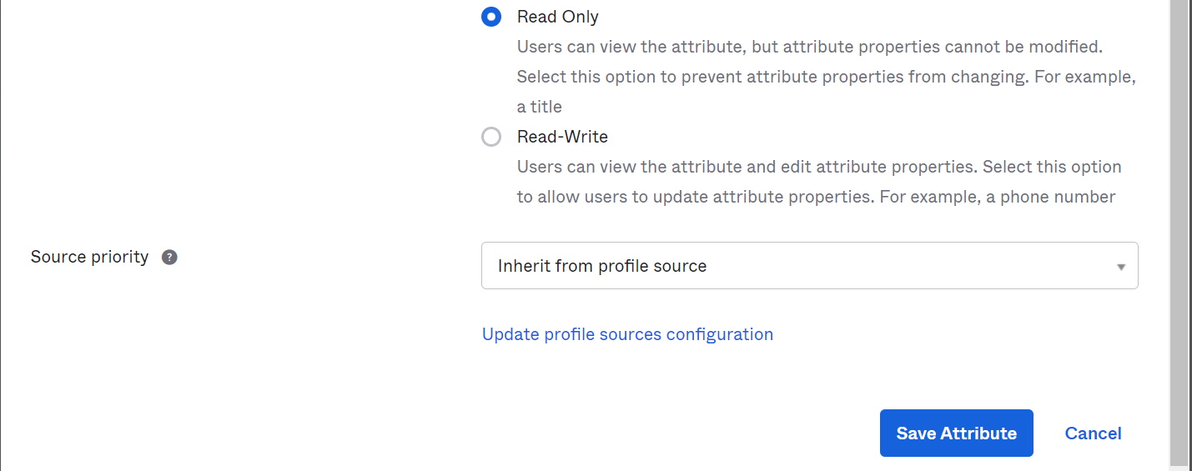

Create custom attribute in Okta User (default) profile for Org2Org admin setup- eid and uid

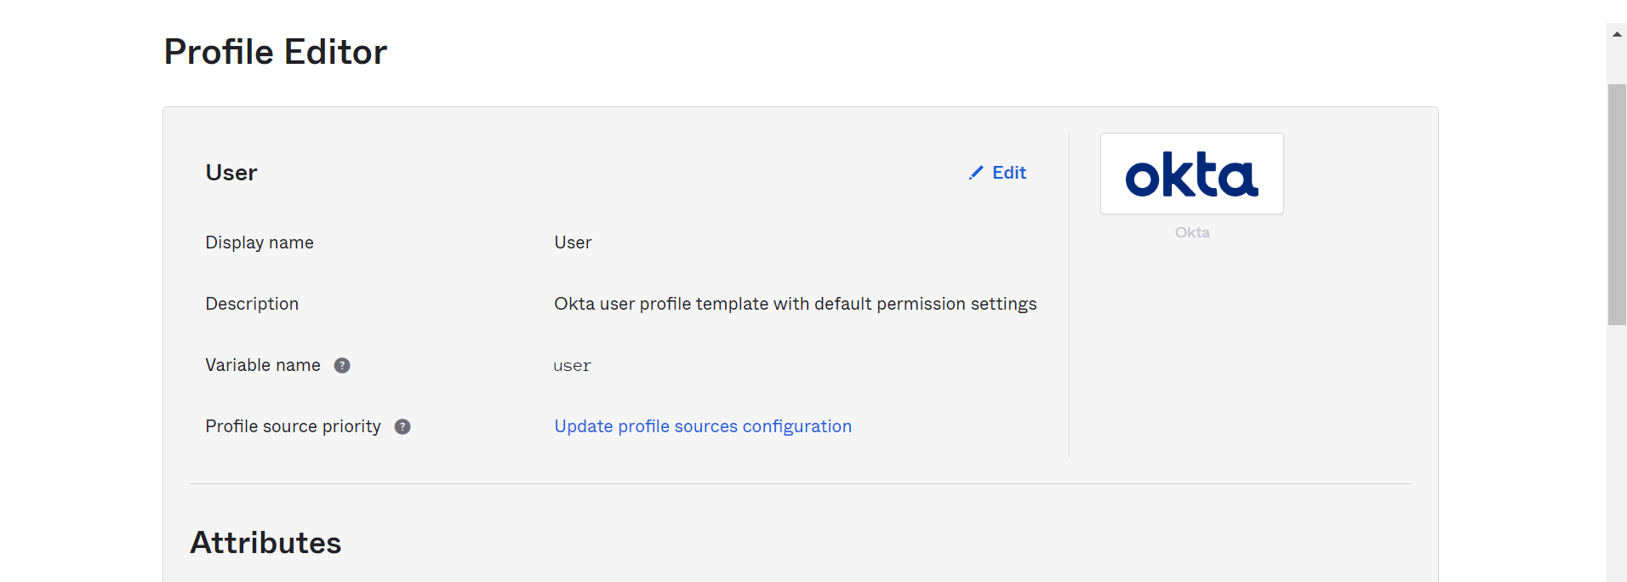

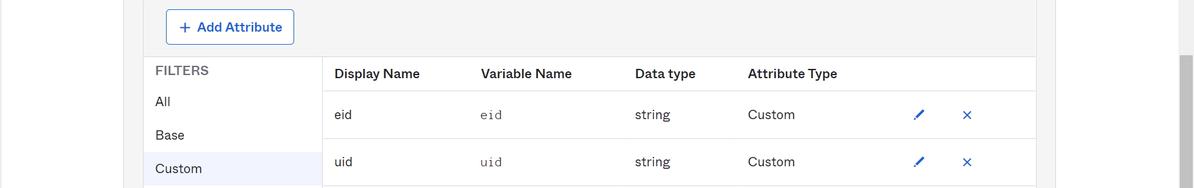

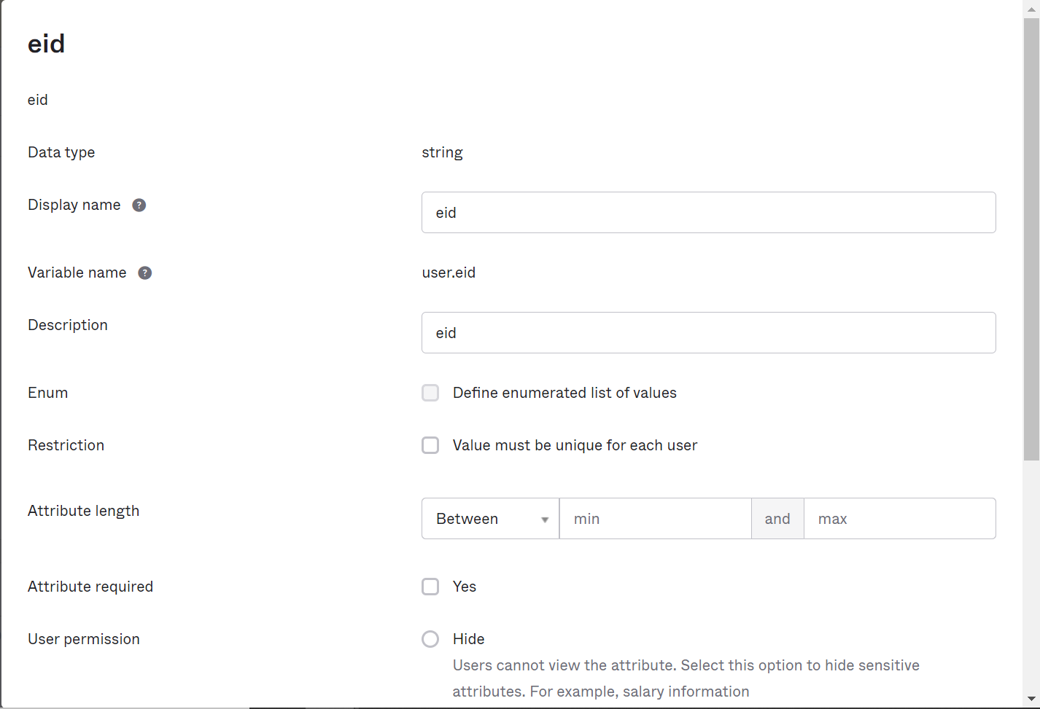

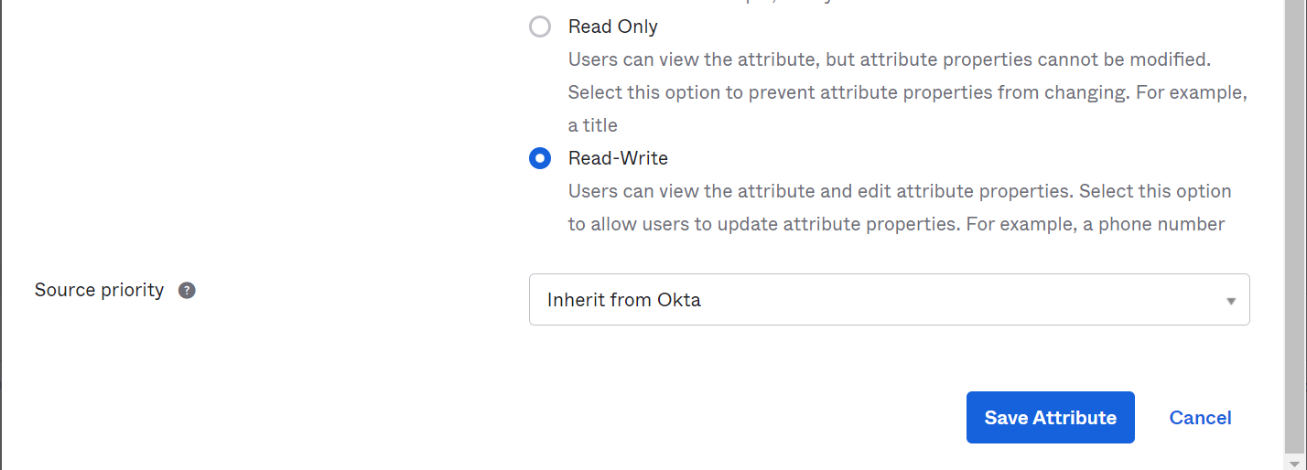

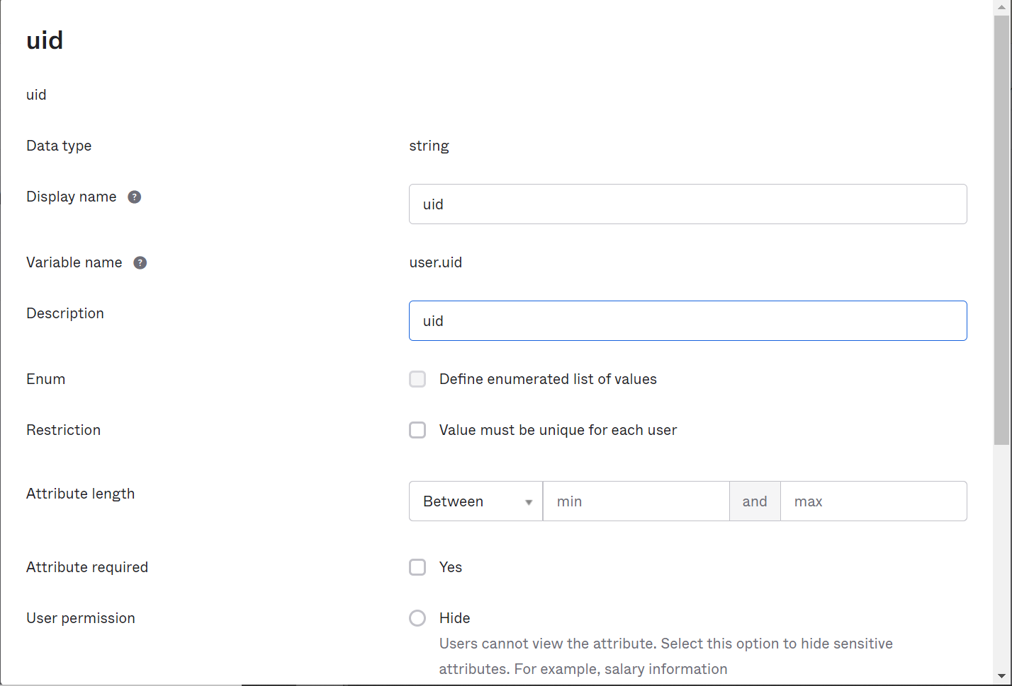 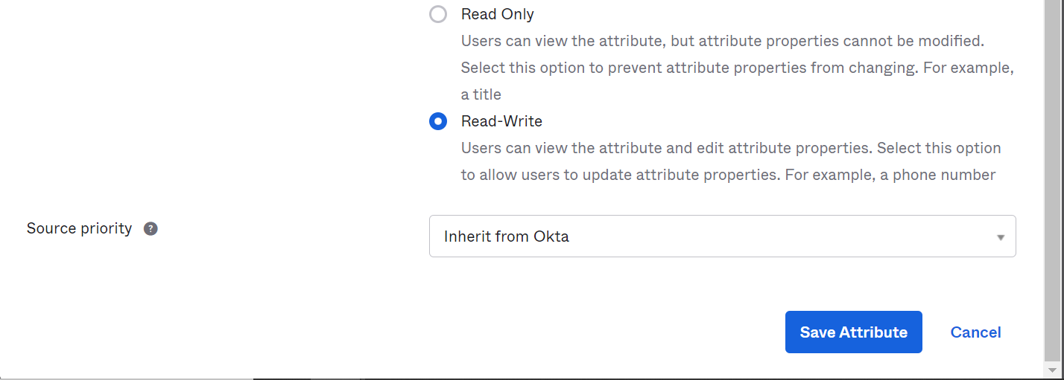

### [Okta B2E UAT User](https://rxservices-admin.oktapreview.com/admin/universaldirectory)

#### Profile

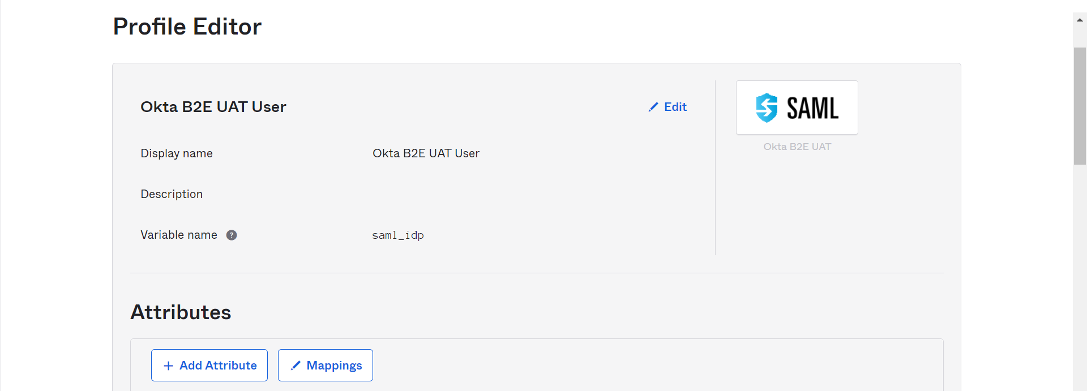

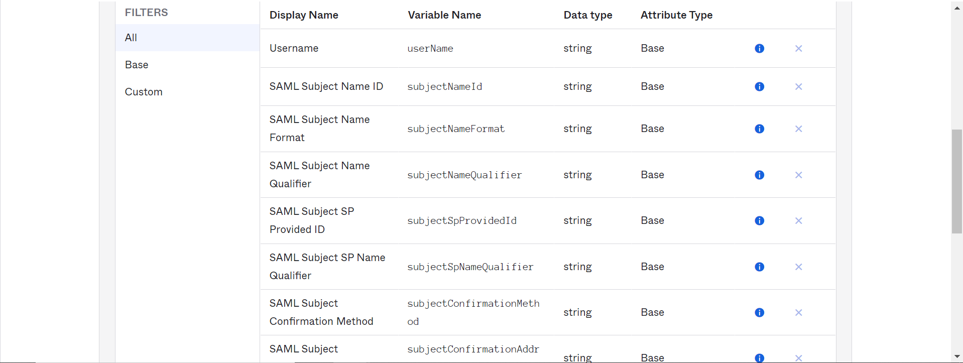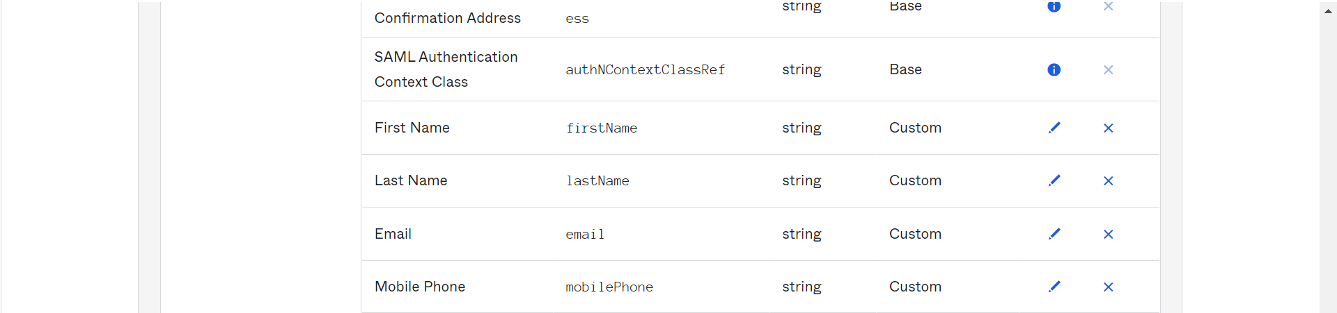

#### Mapping

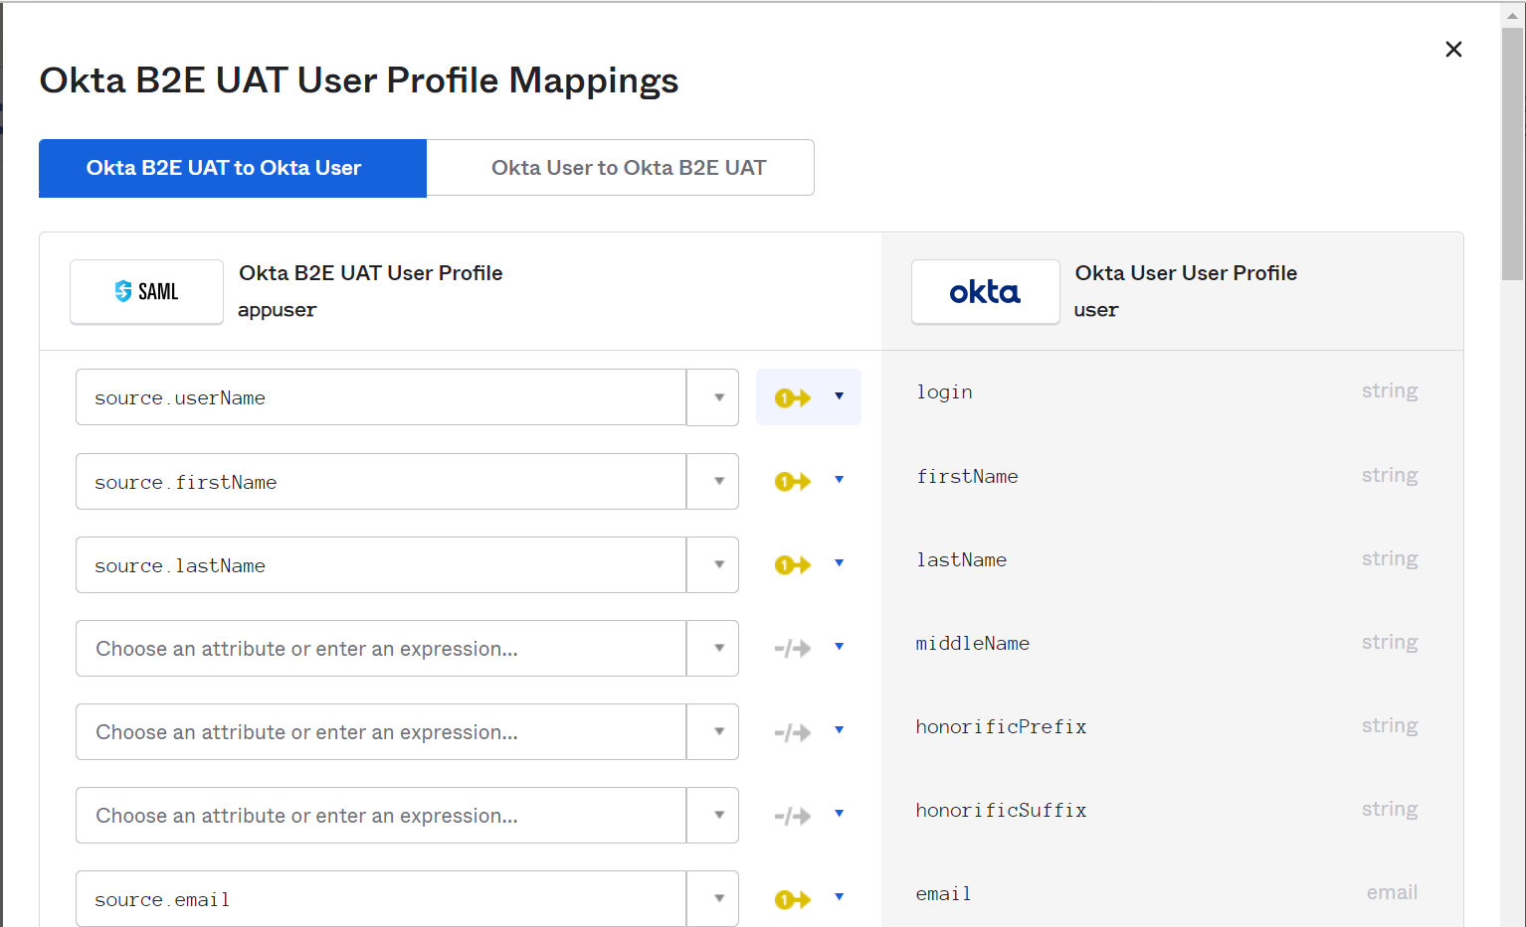

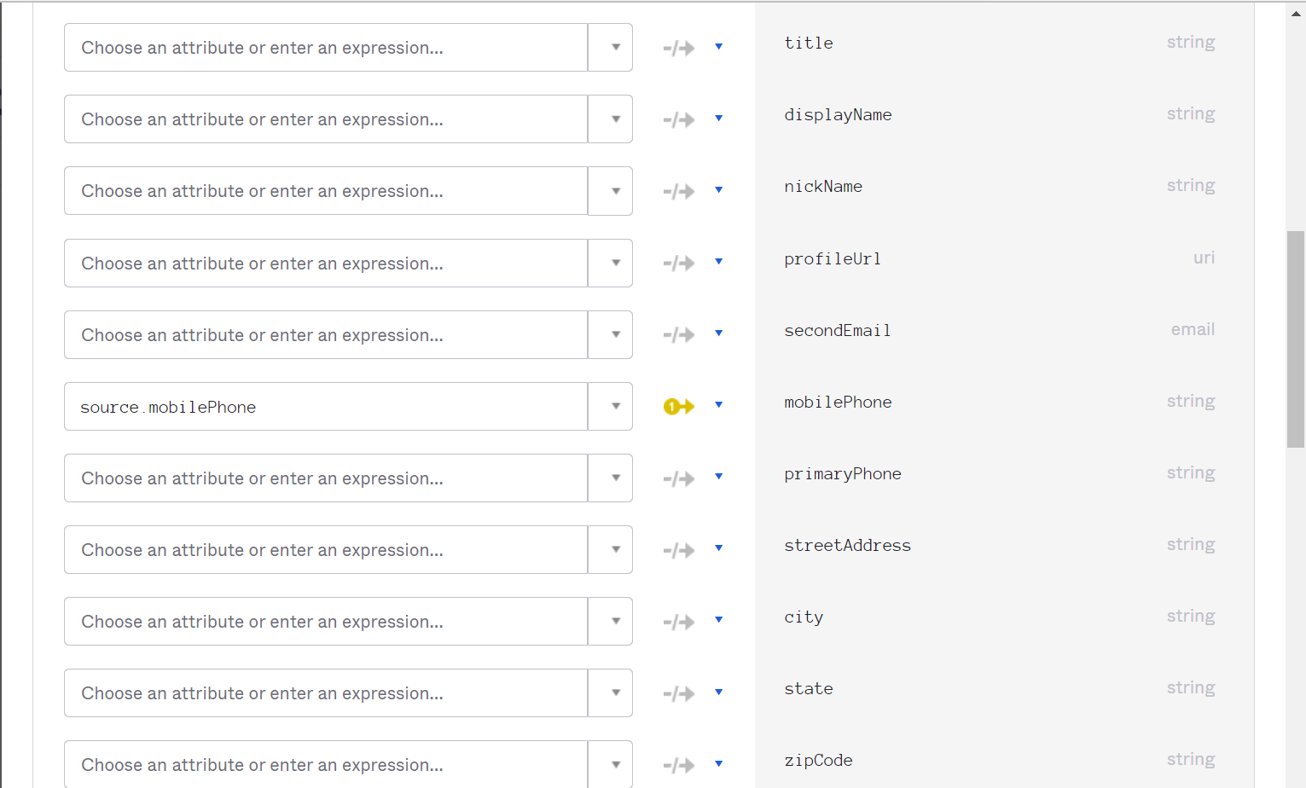

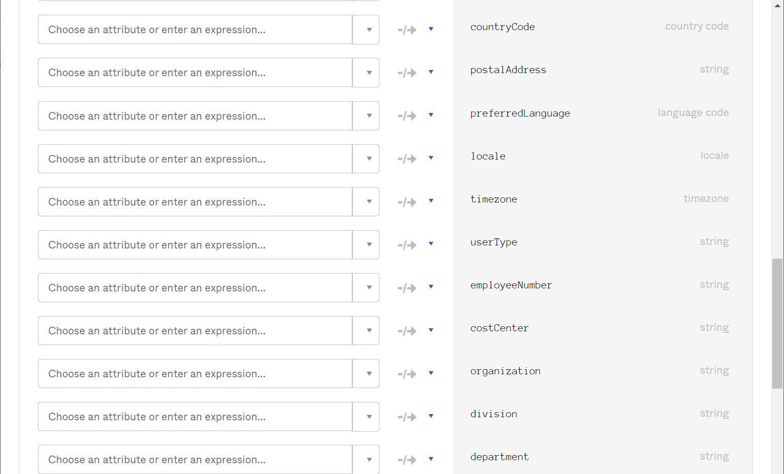

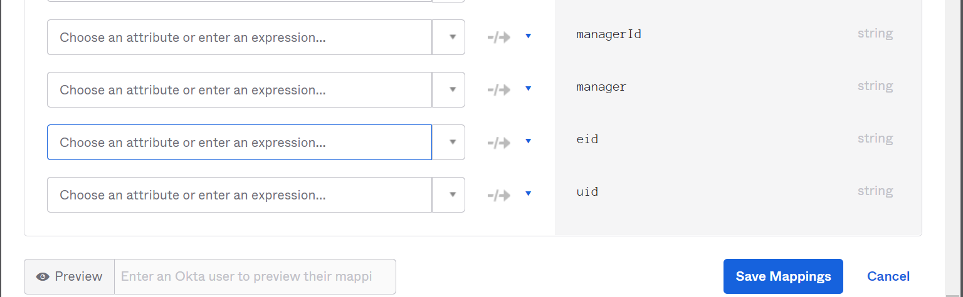

### Biologics Portal Users

#### Profile

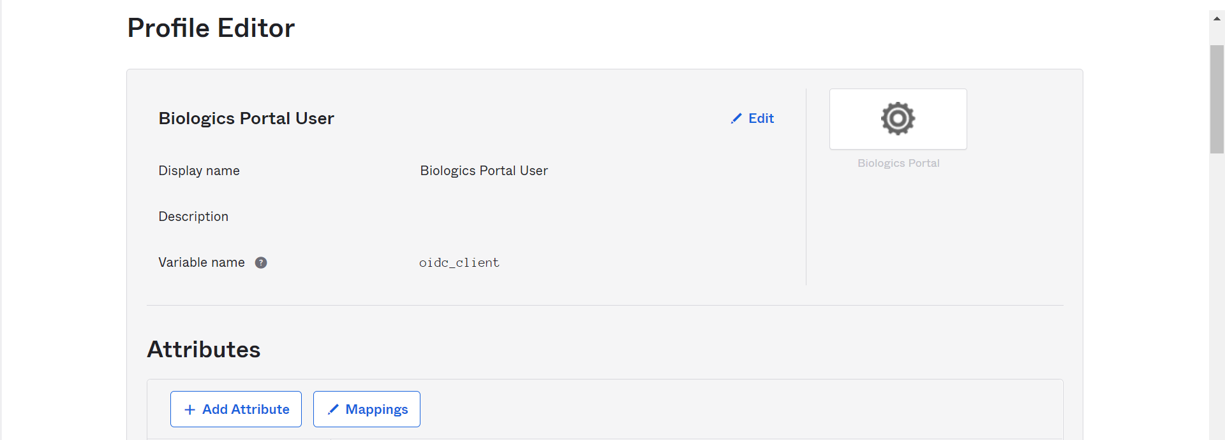

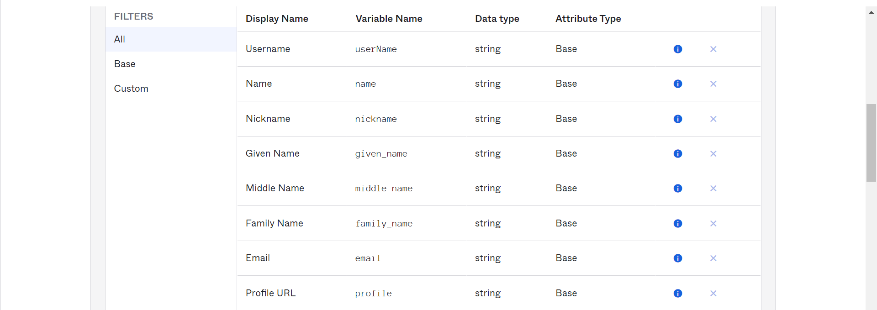

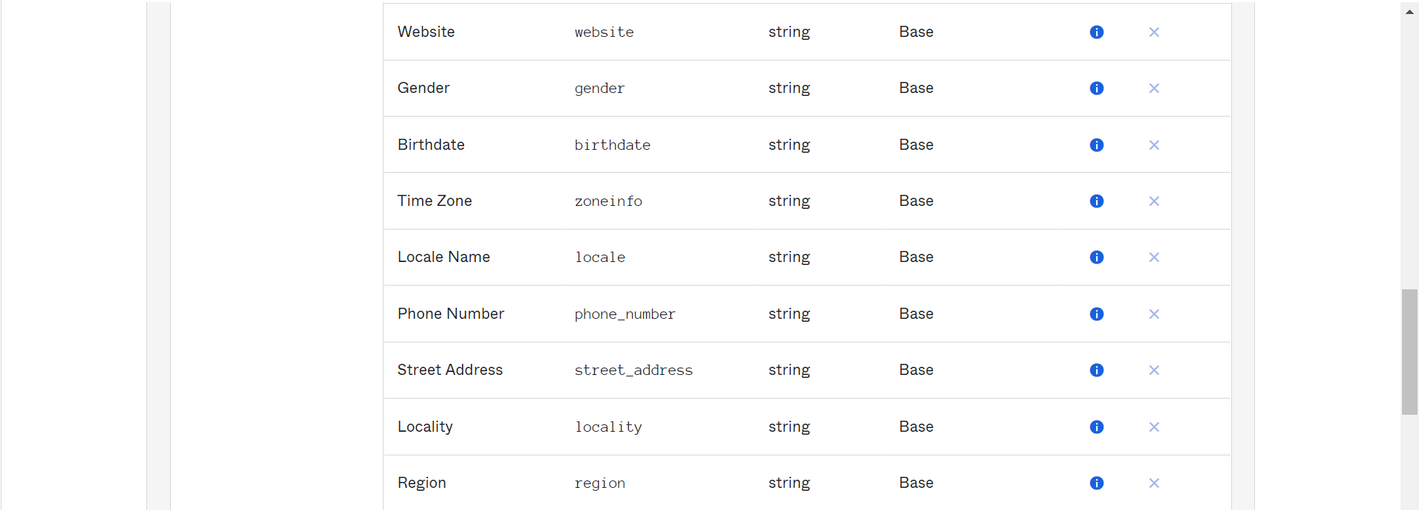



#### Mapping

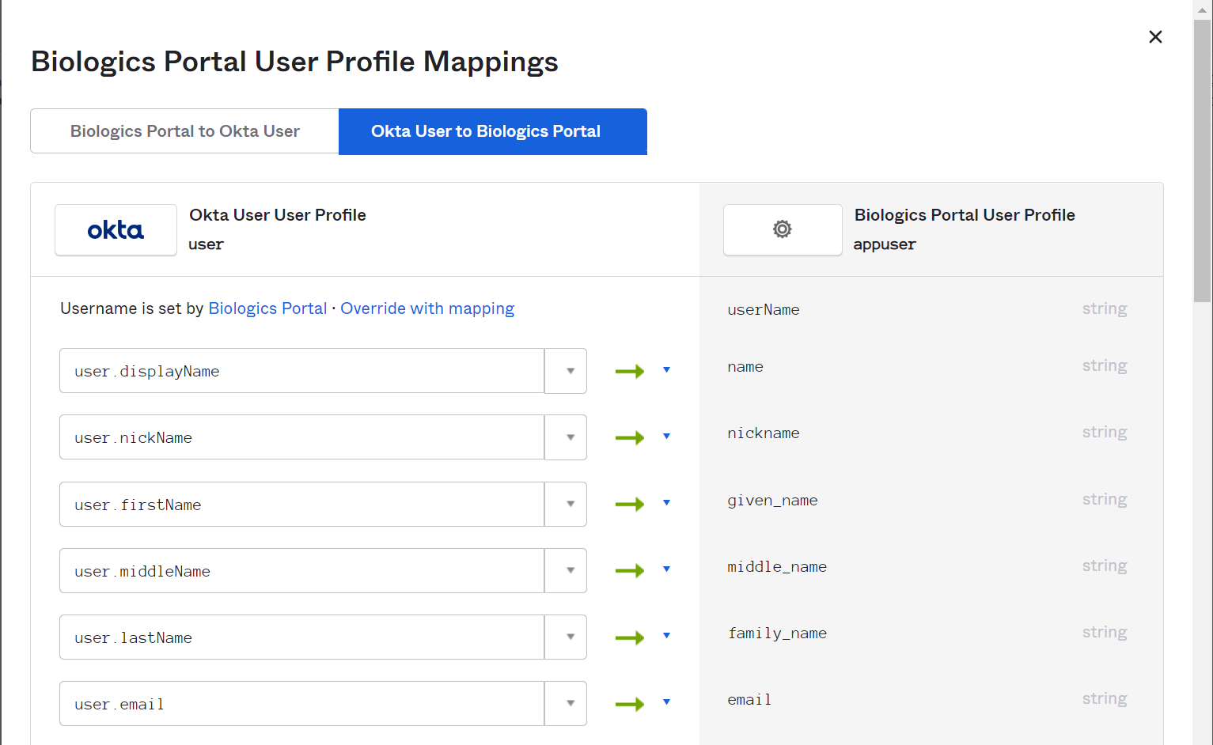

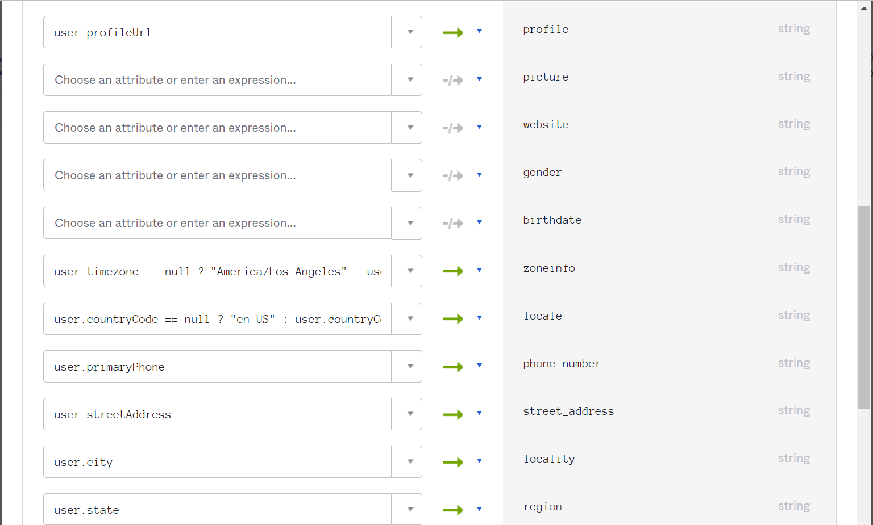

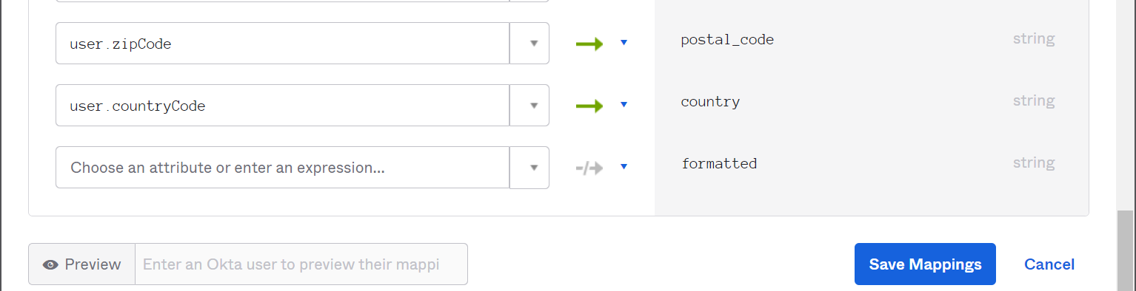

### Okta B2E UAT Appuser User

#### Profile

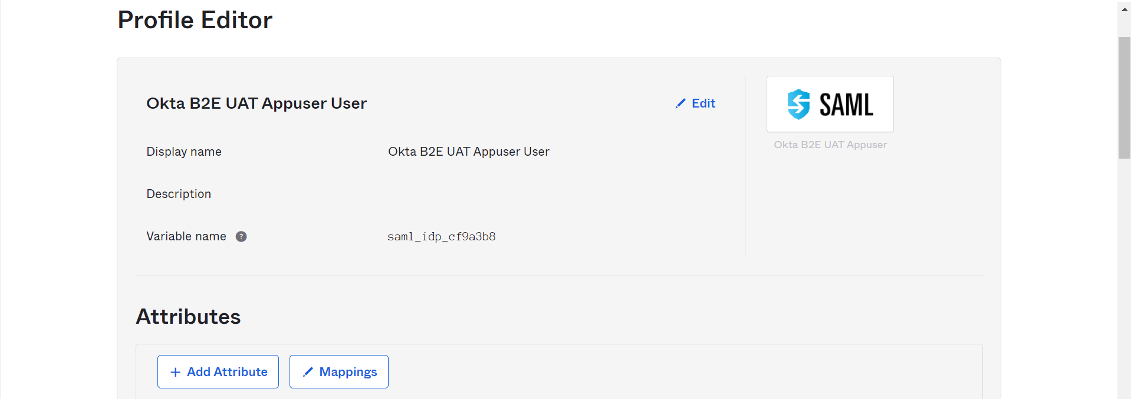

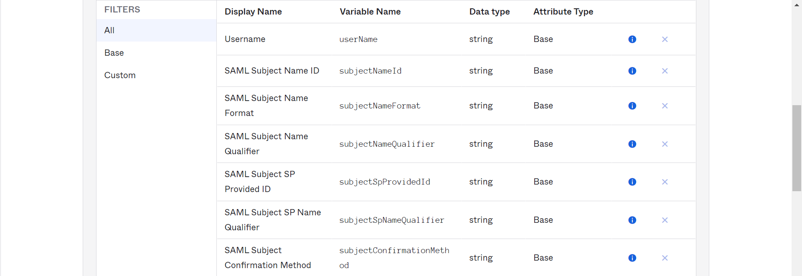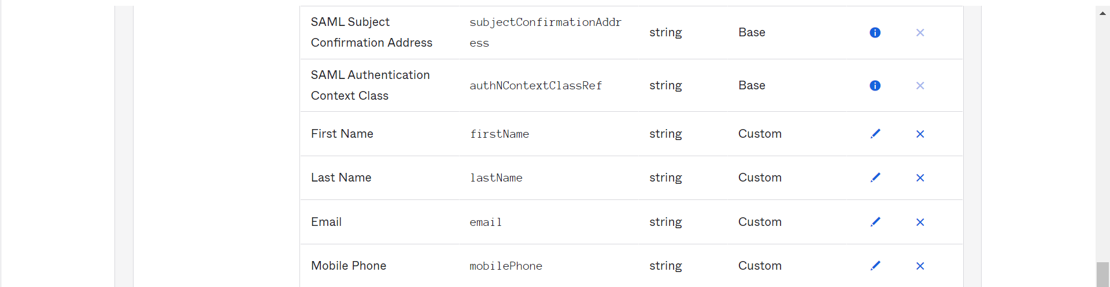

#### Mapping

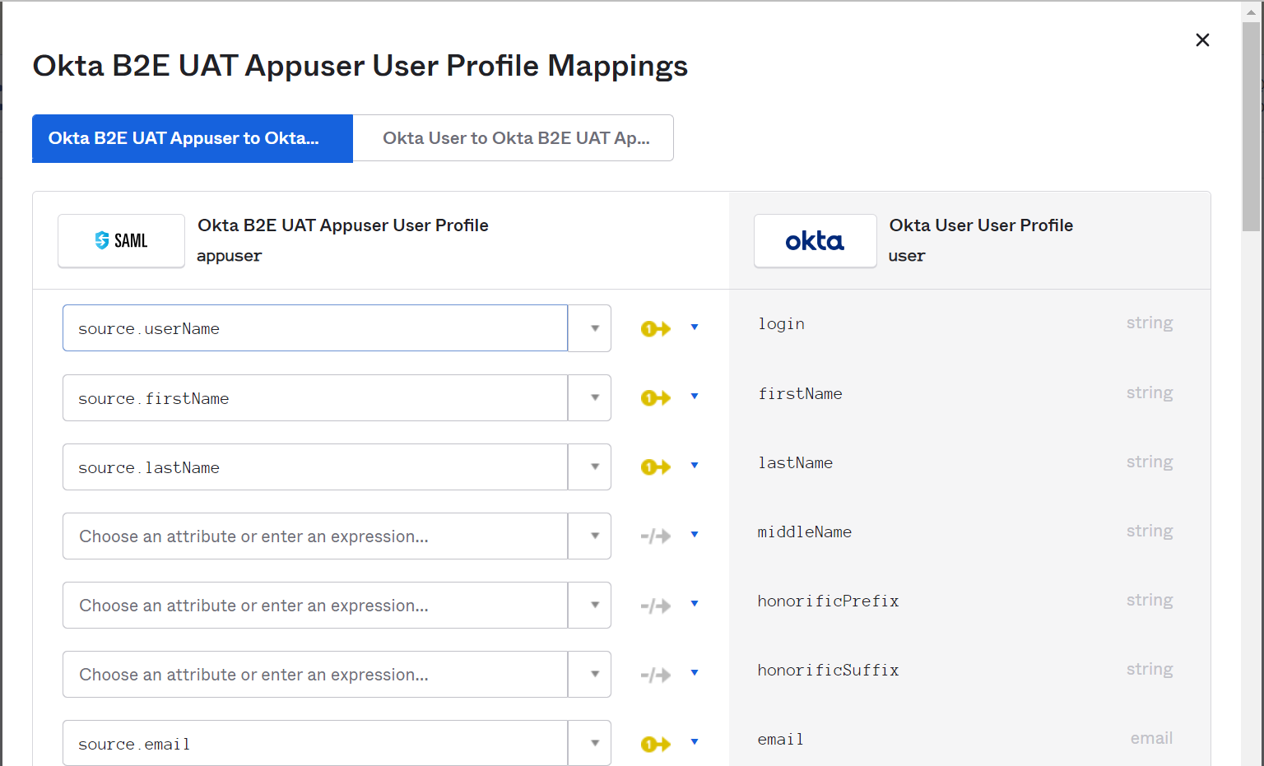

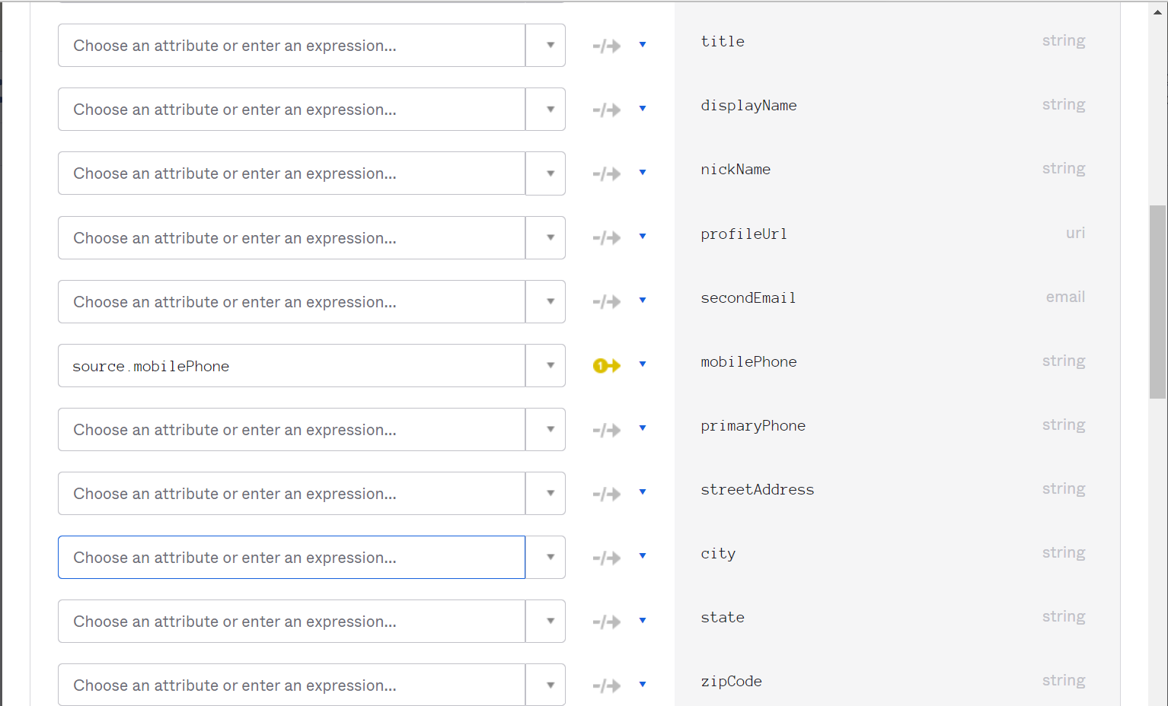

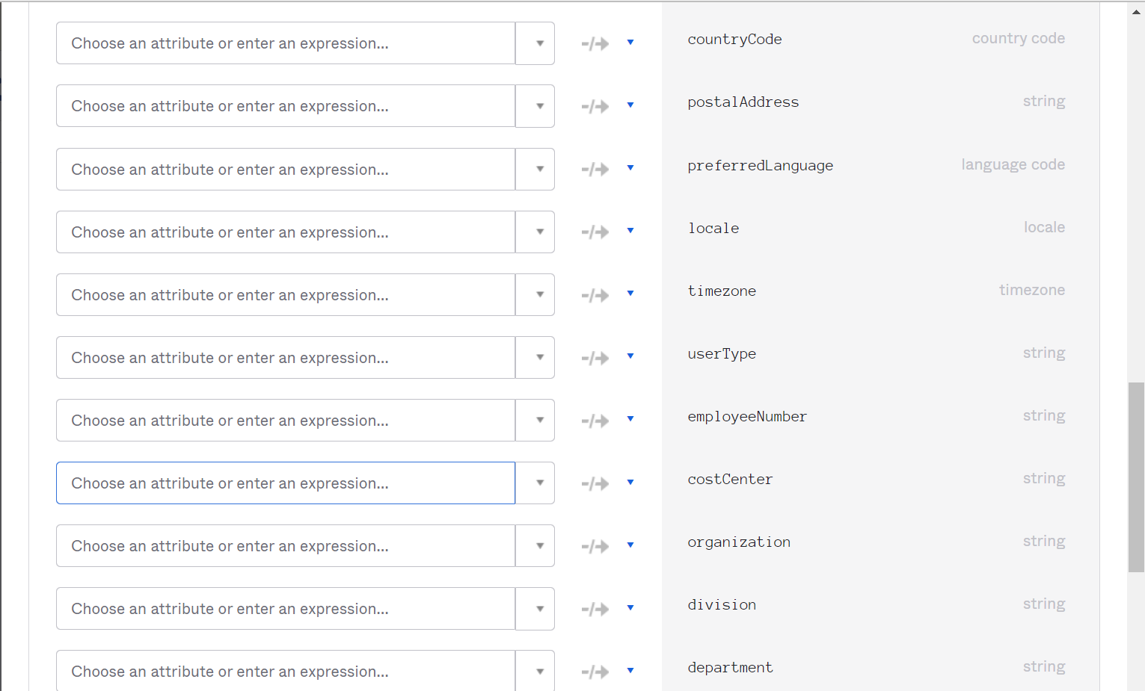

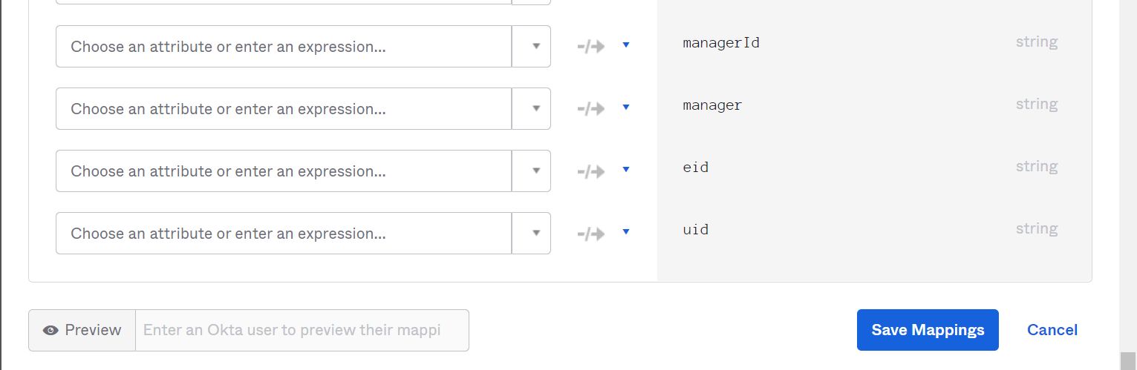

# Applications

## Application

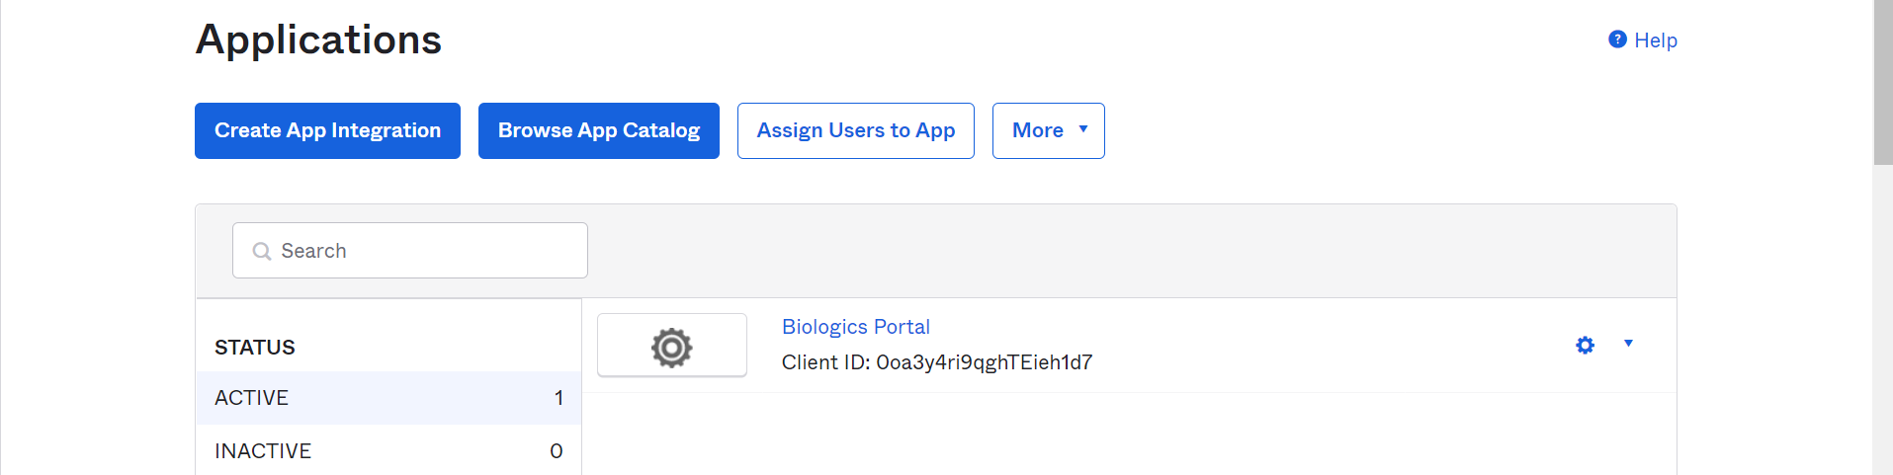

### General

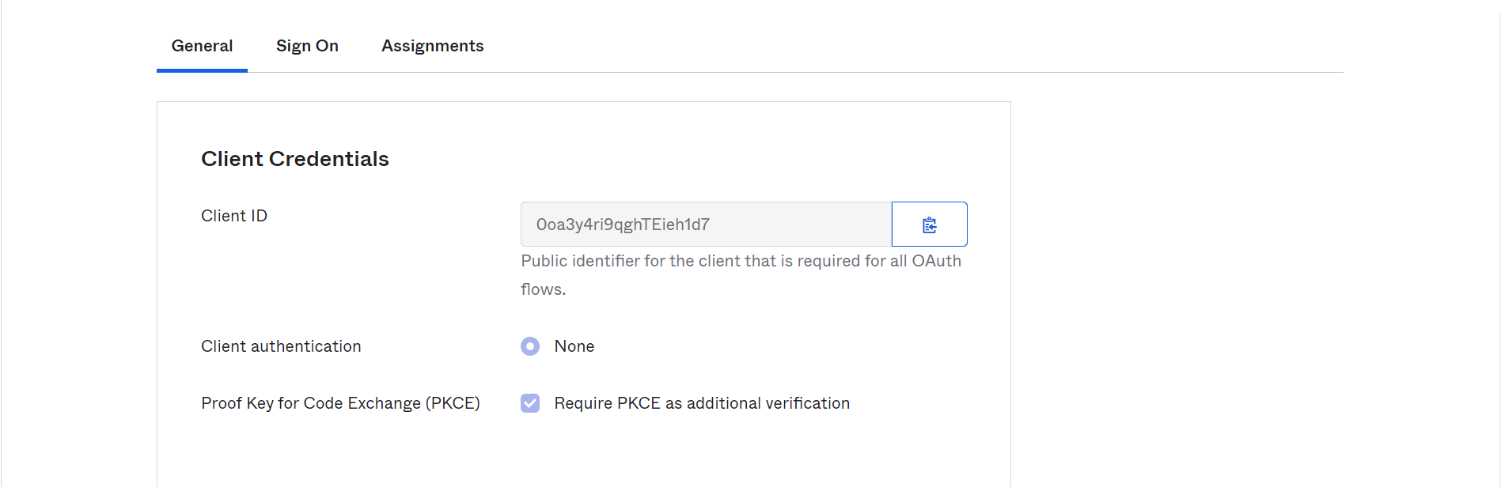

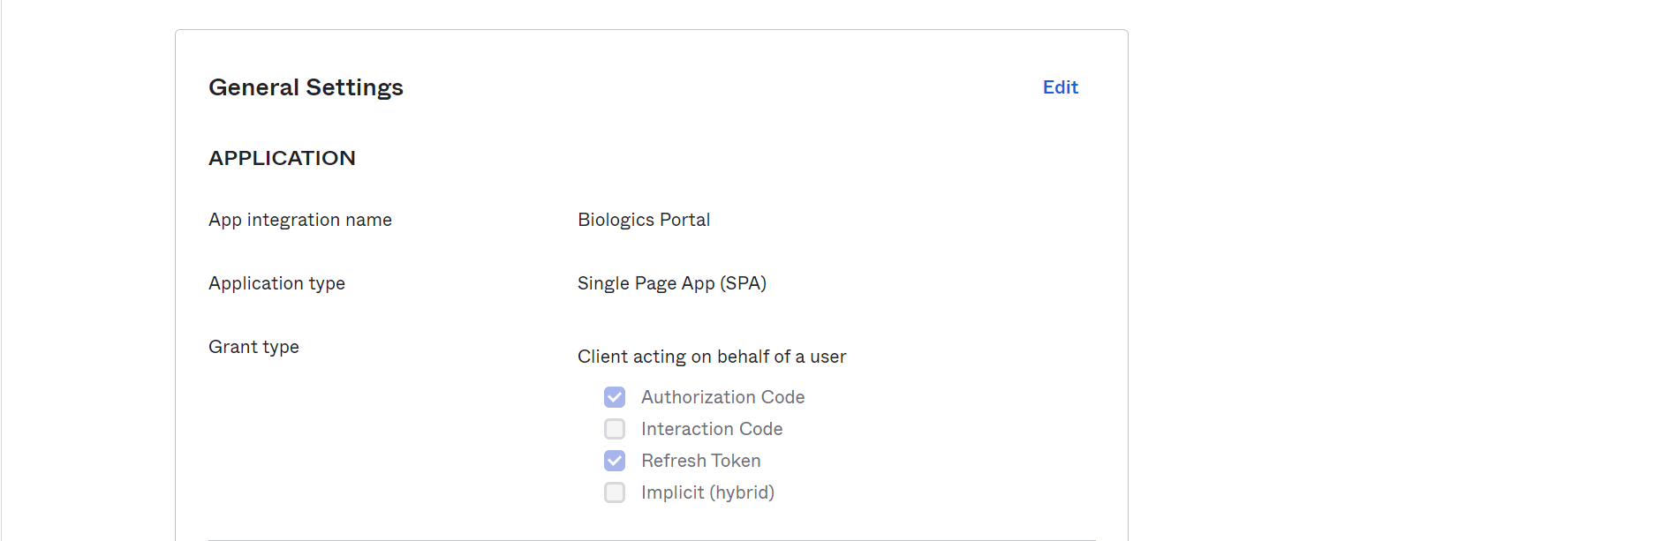

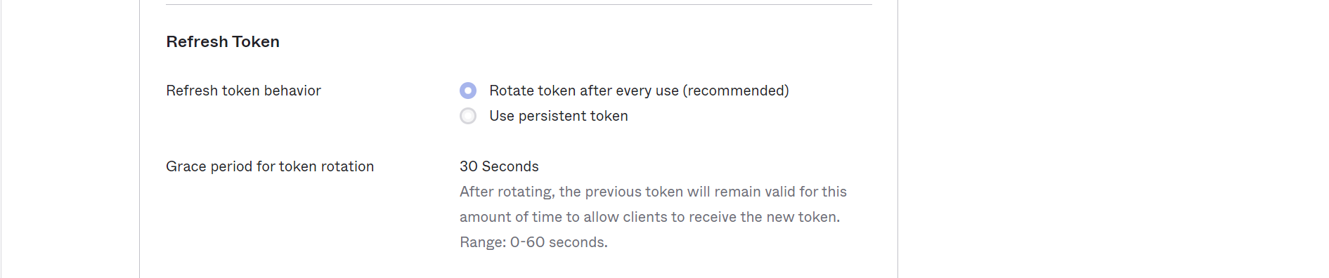

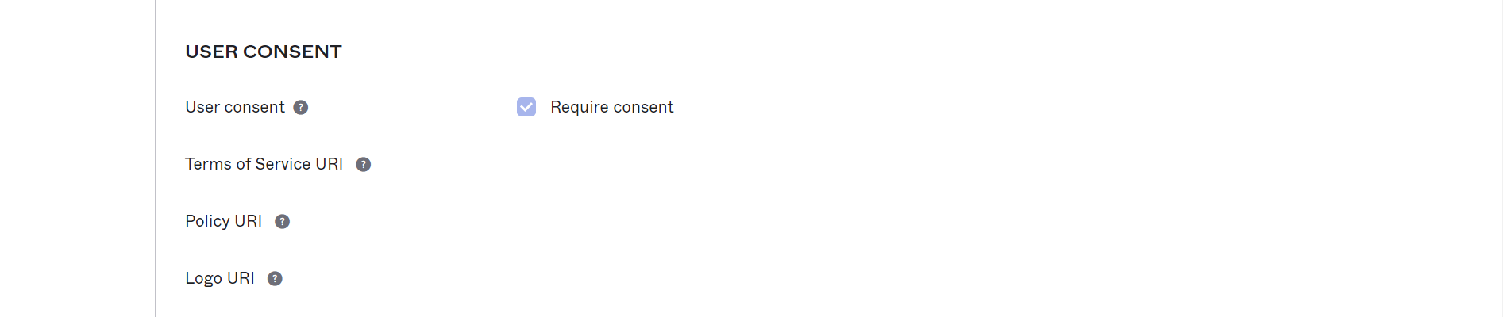

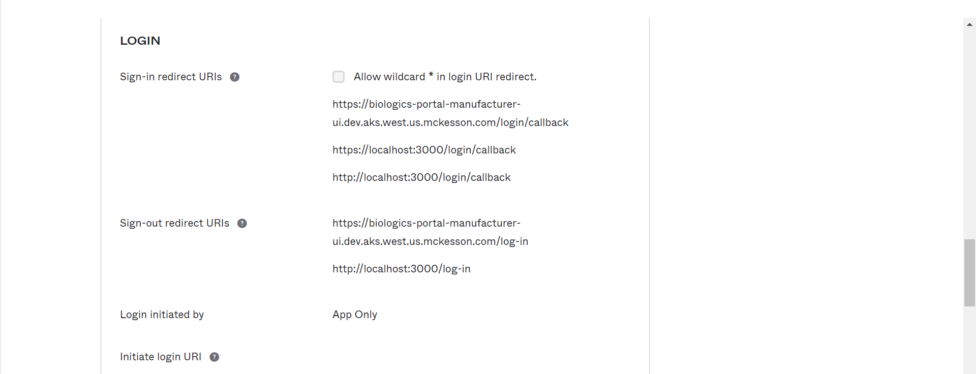

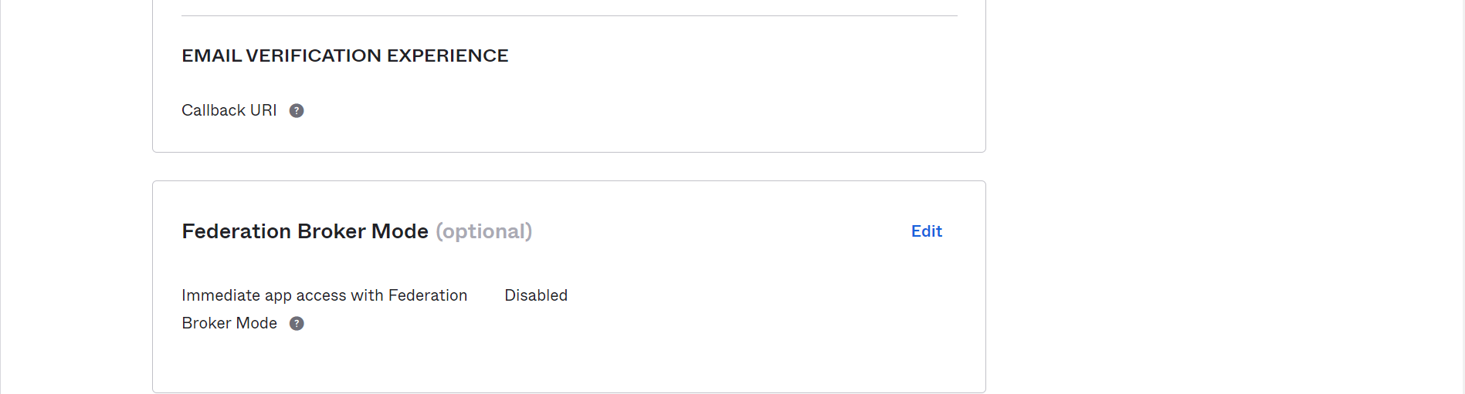

### Sign On

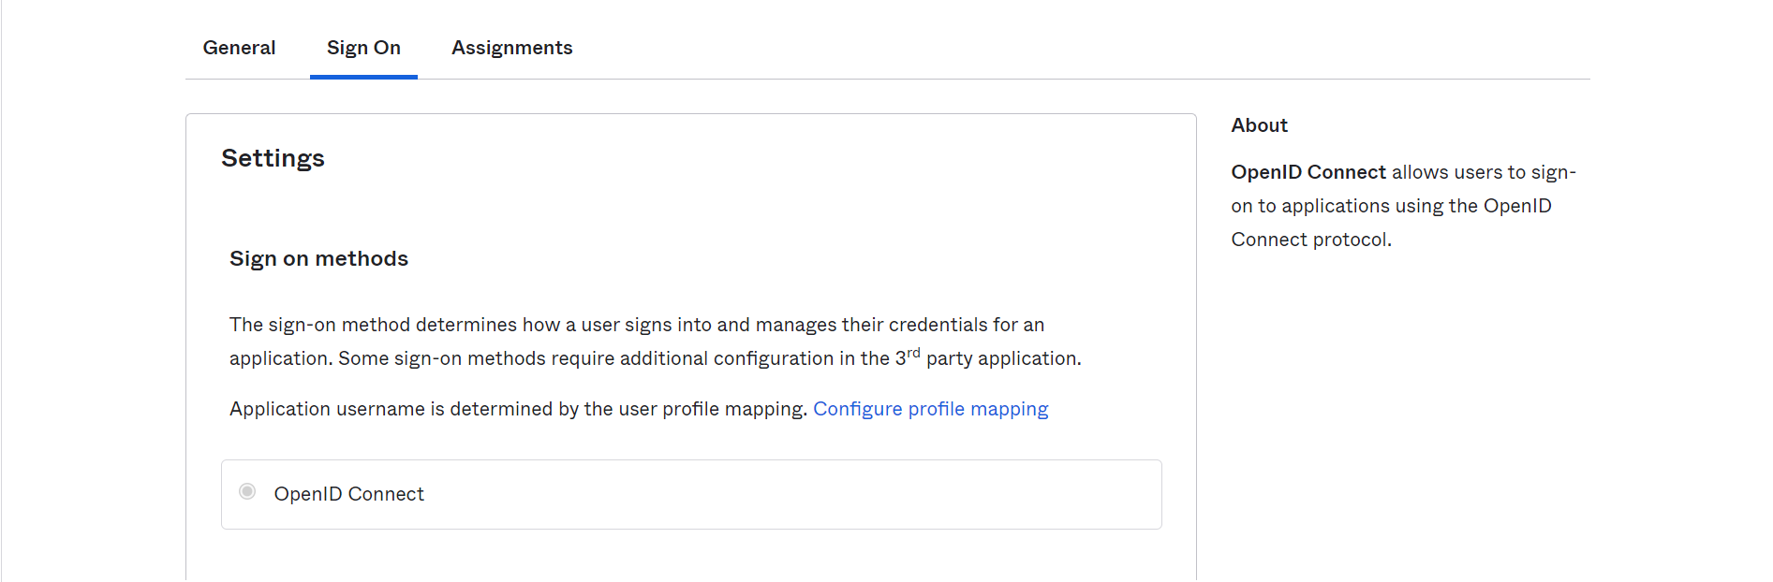



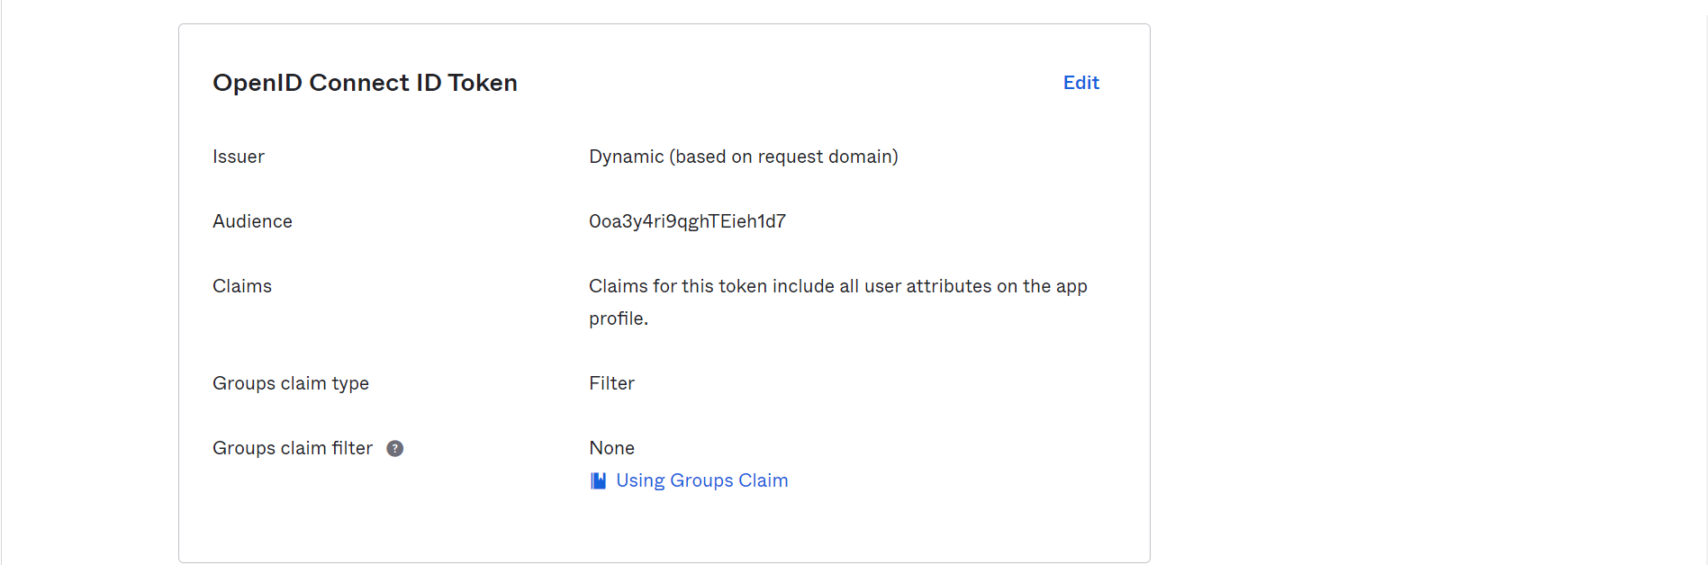 

### Assignments

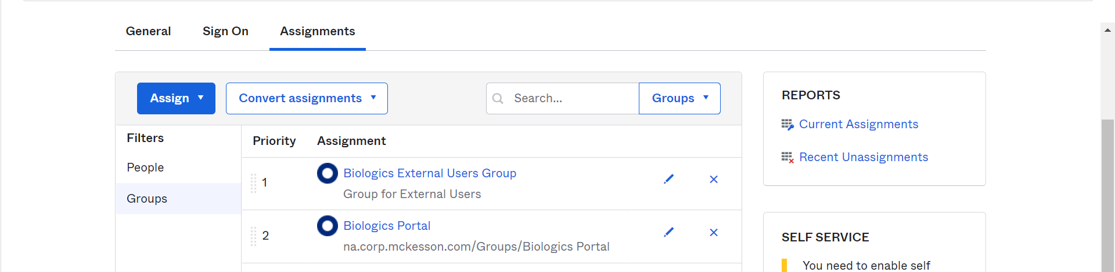

# Security

## Authenticators

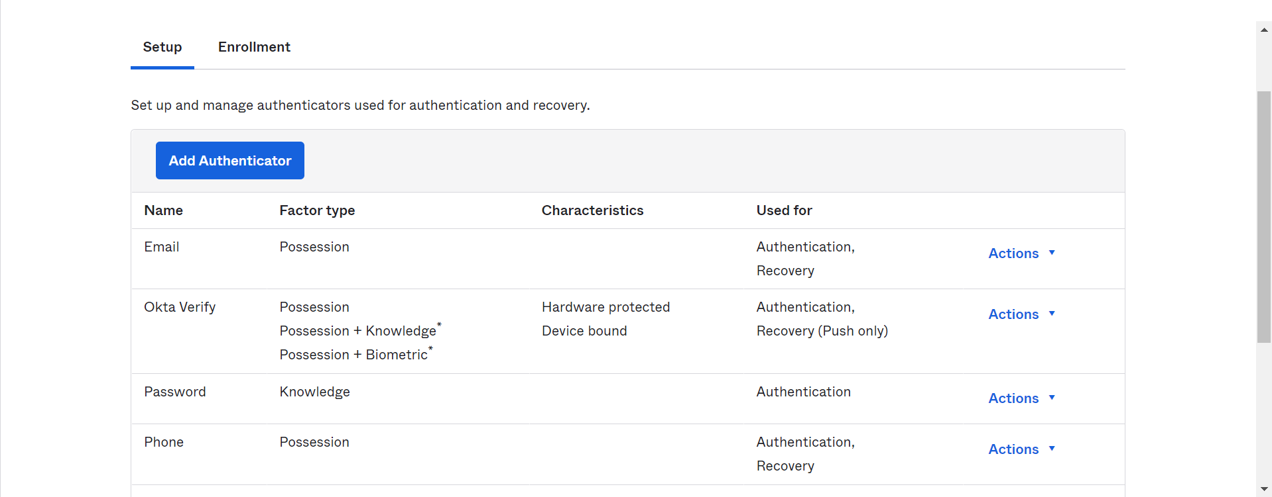

### Enrollment

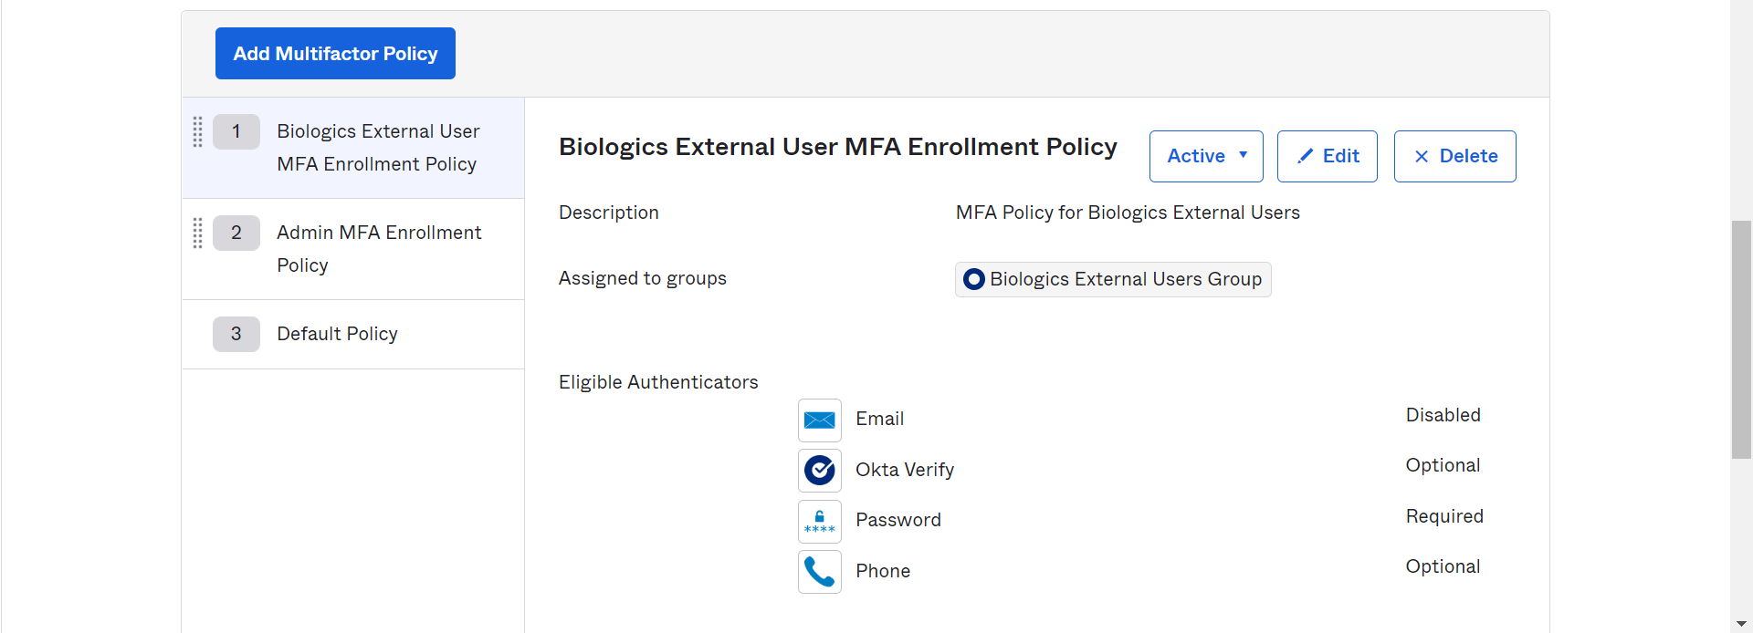



### Setup

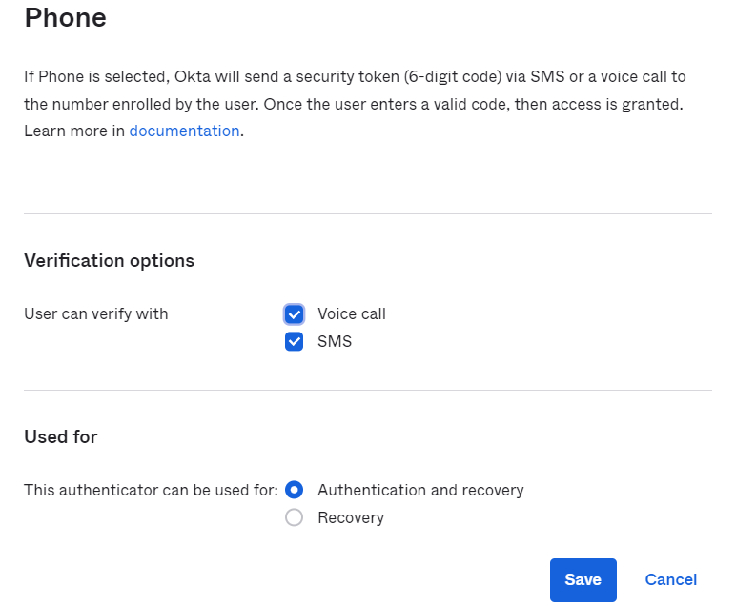

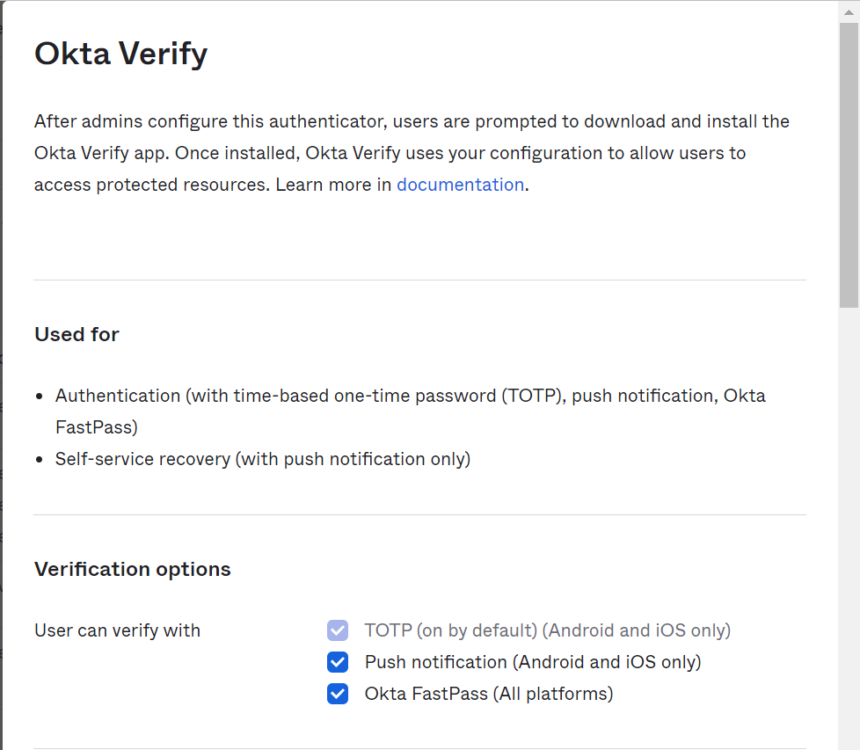

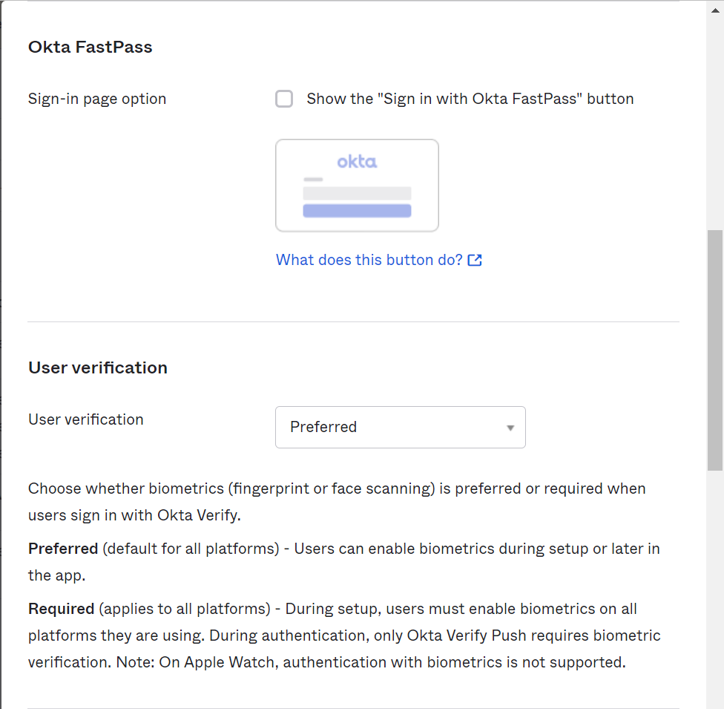

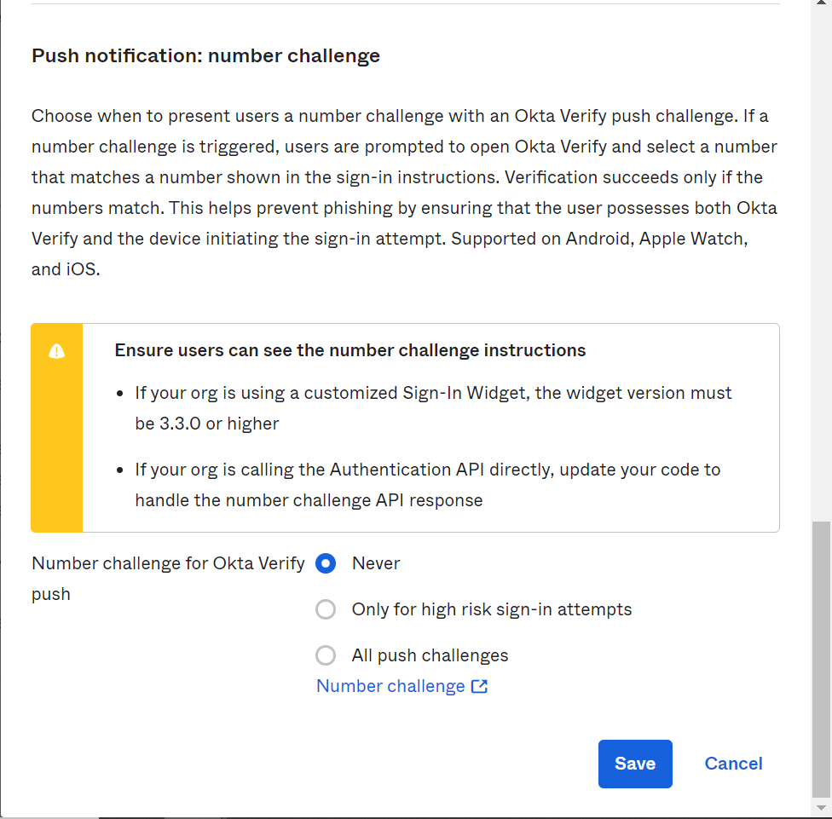

## Authentication policies

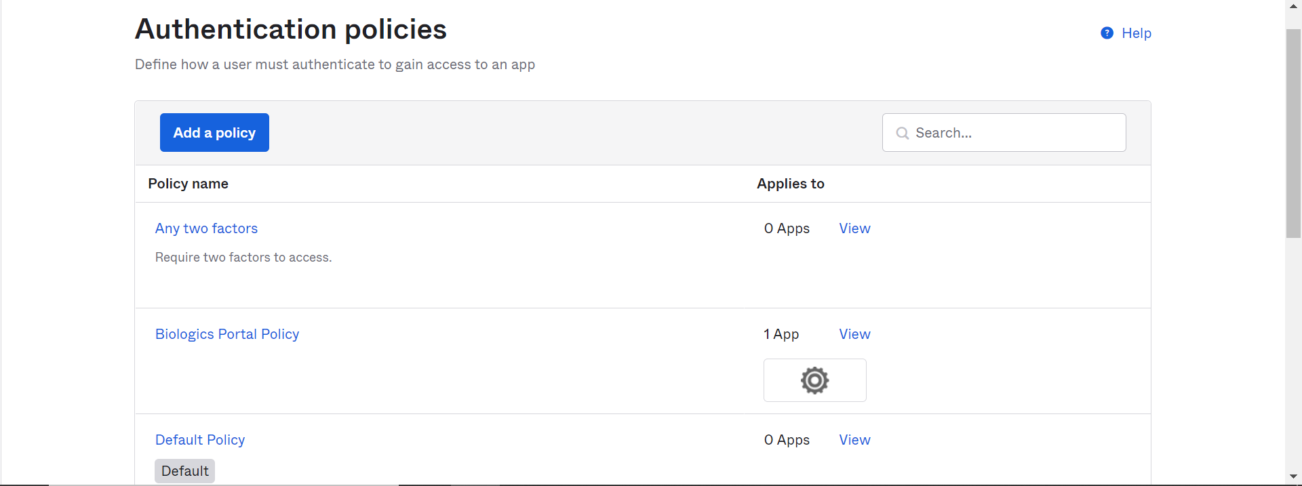

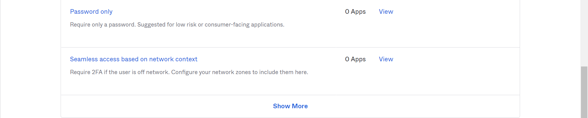

## Identity Providers

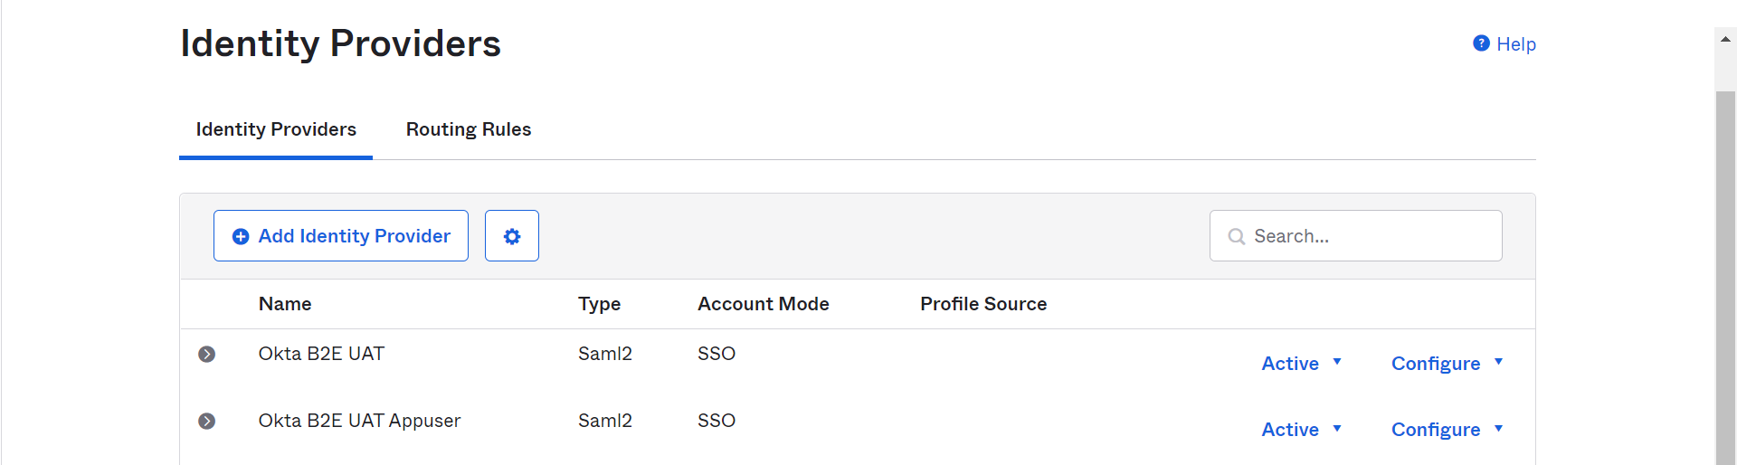

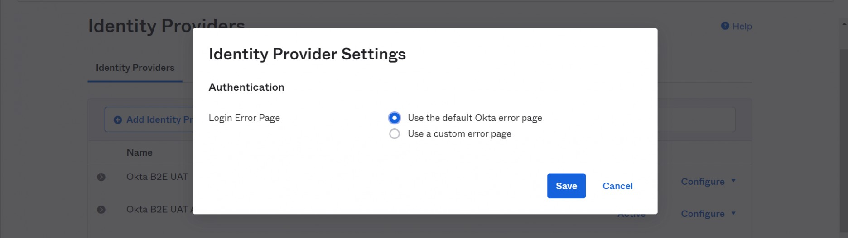

### Okta B2E UAT

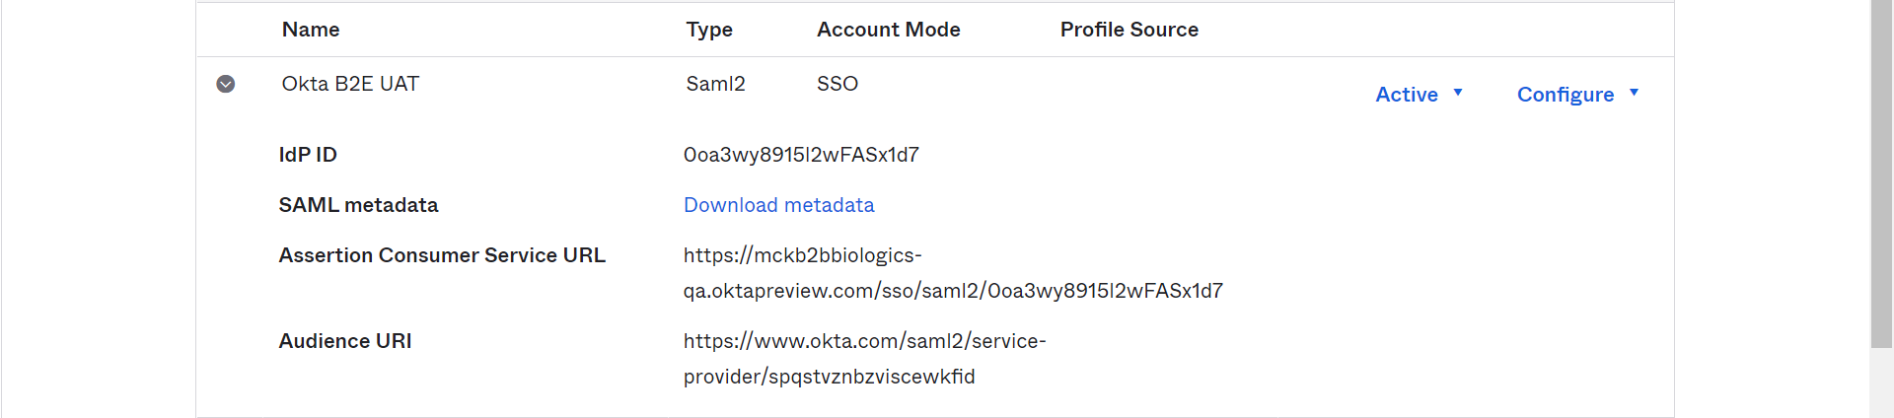

#### Configuration

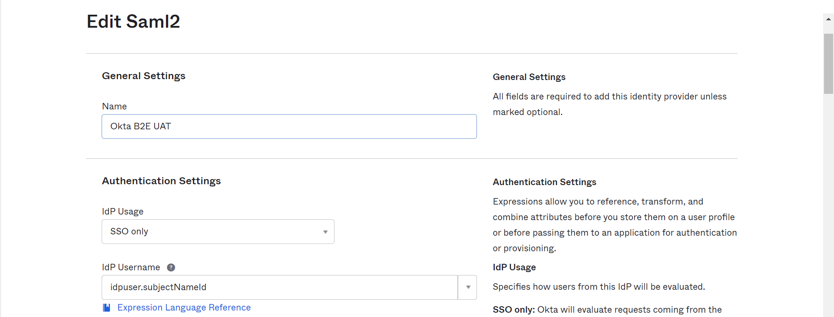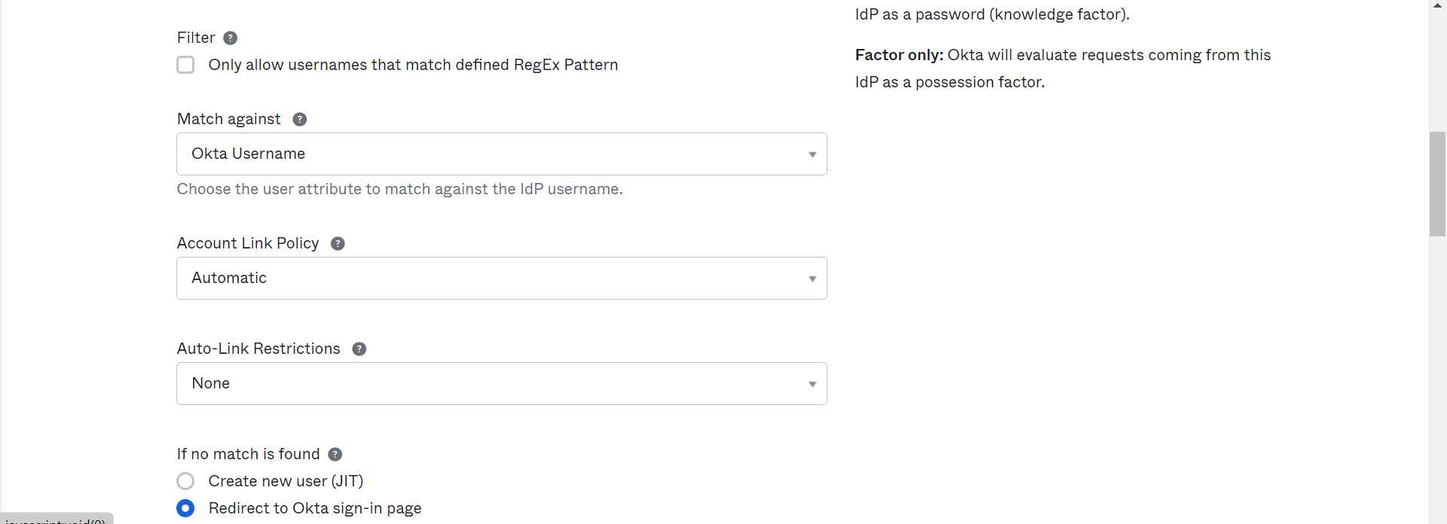

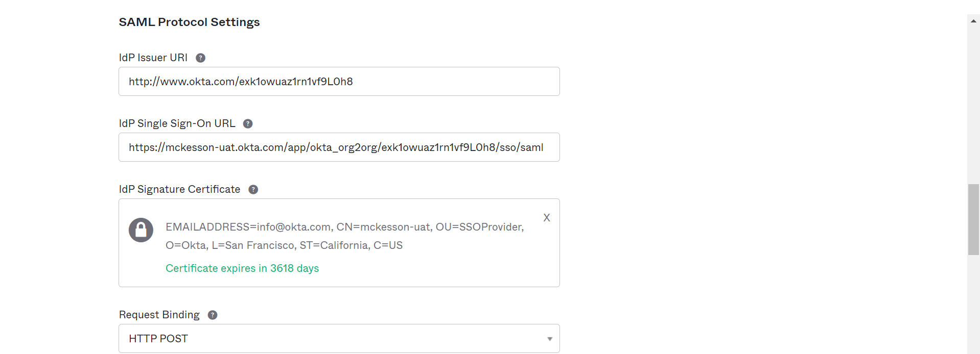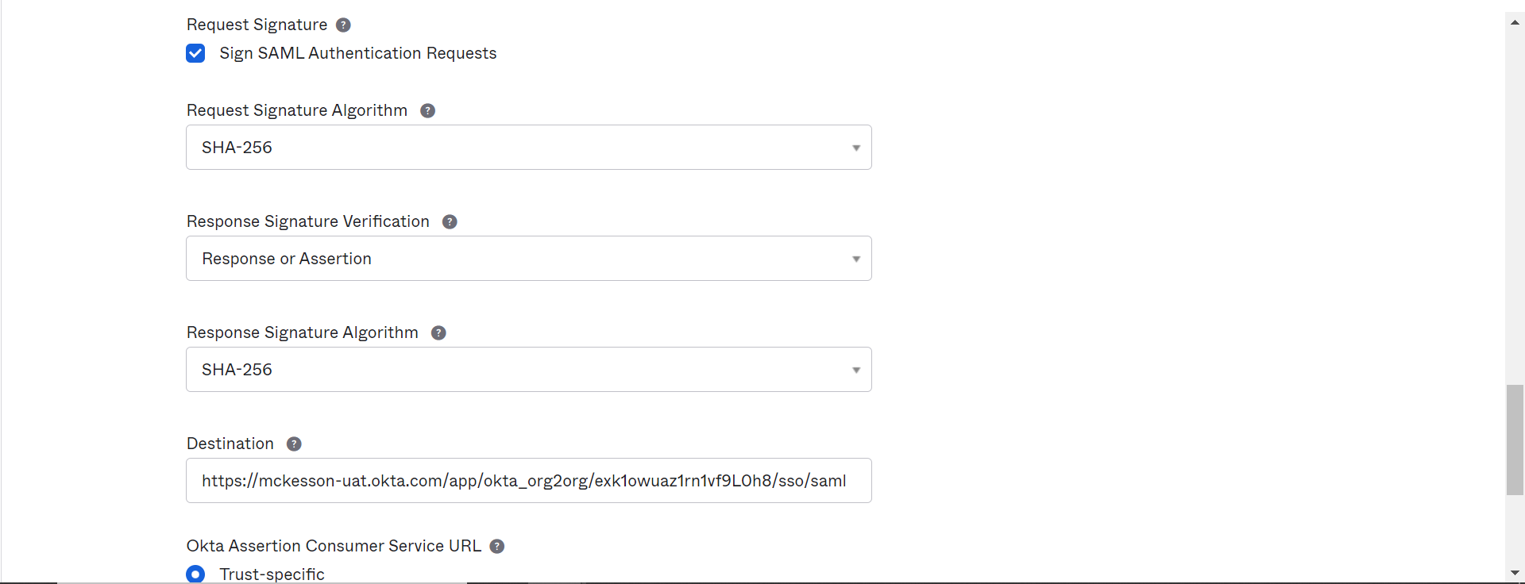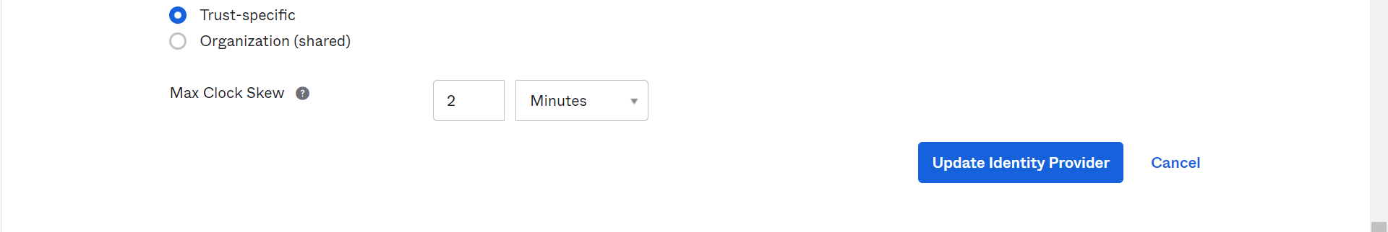

#### Edit Profile and Mapping

Refer to Section 3.2.1.2

#### Routing rules

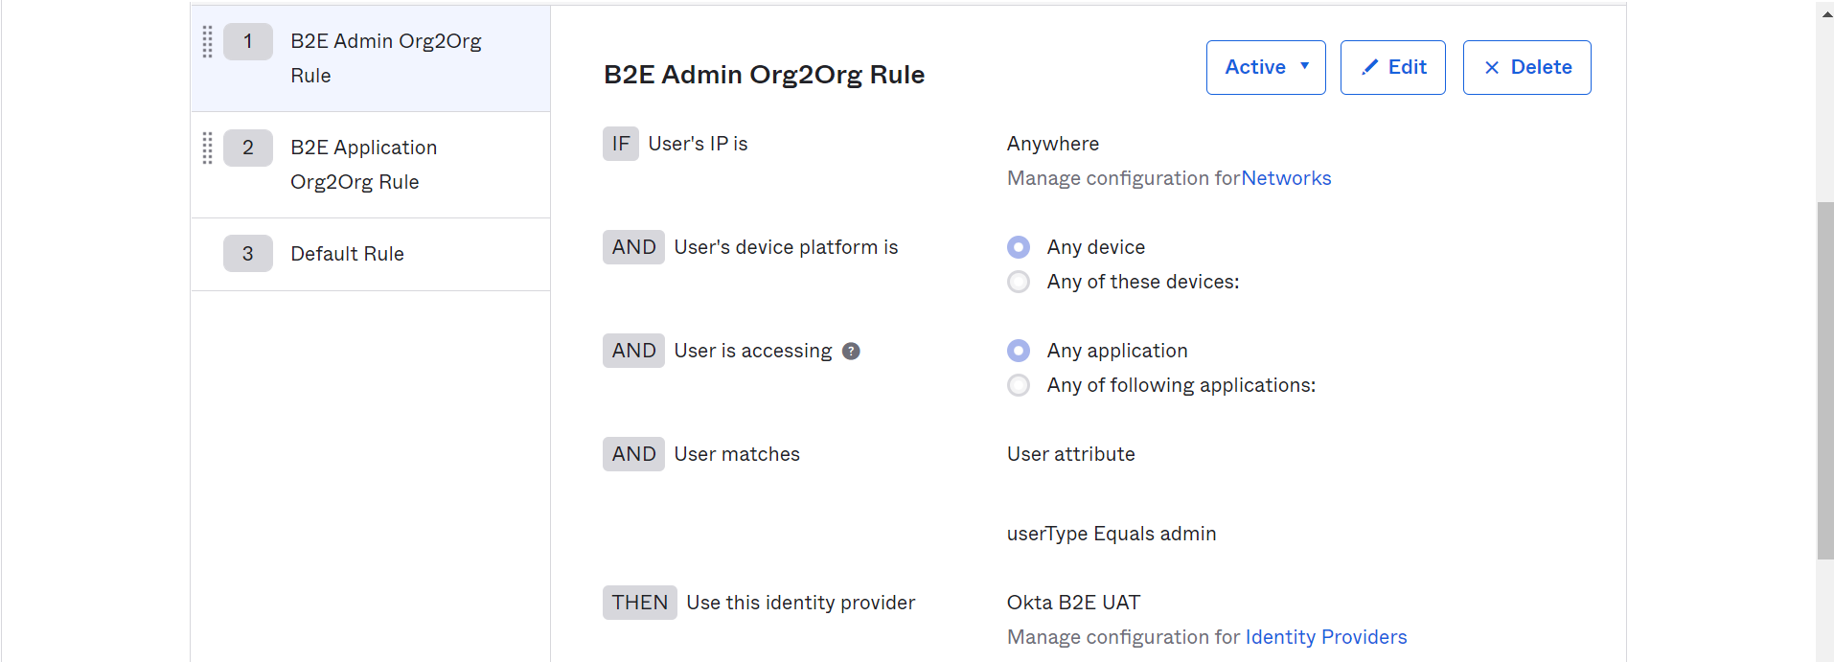

### Okta B2E UAT Appuser

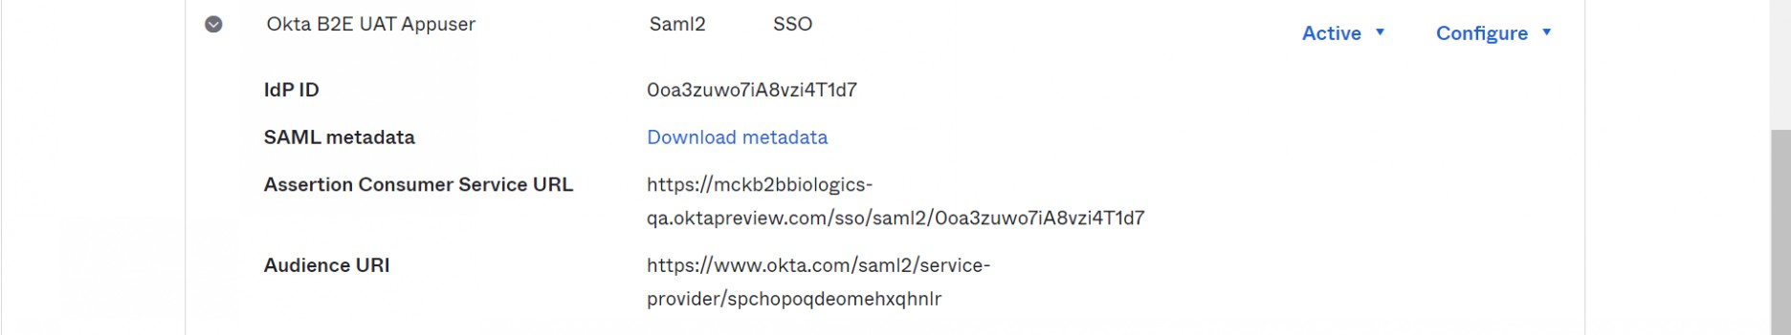

#### Configurations

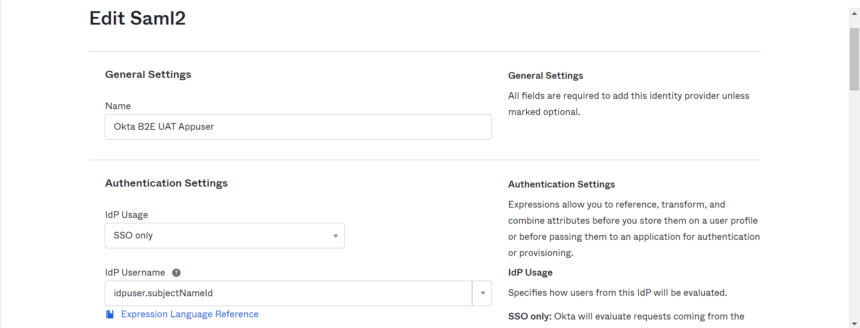

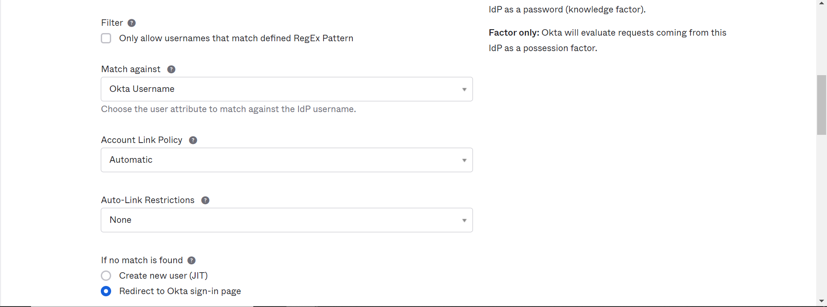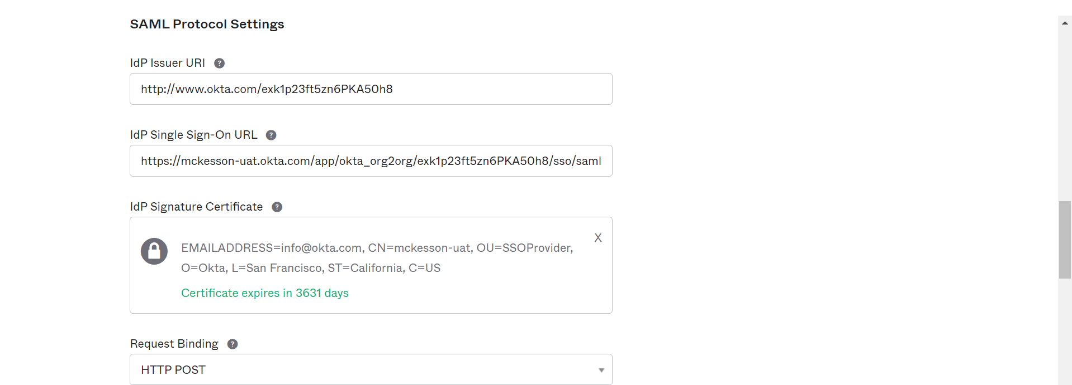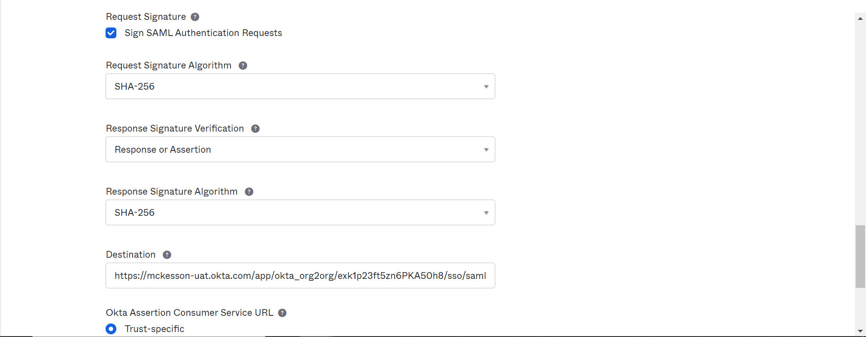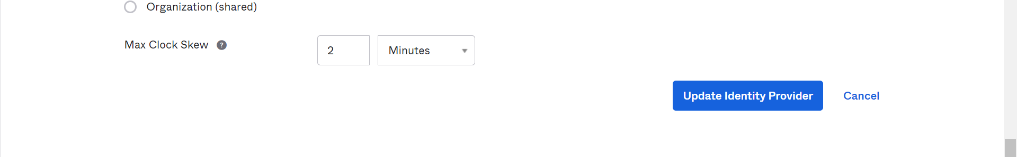

#### Edit Profile and Mapping

Refer to section 3.2.2.2

#### Routing Rules

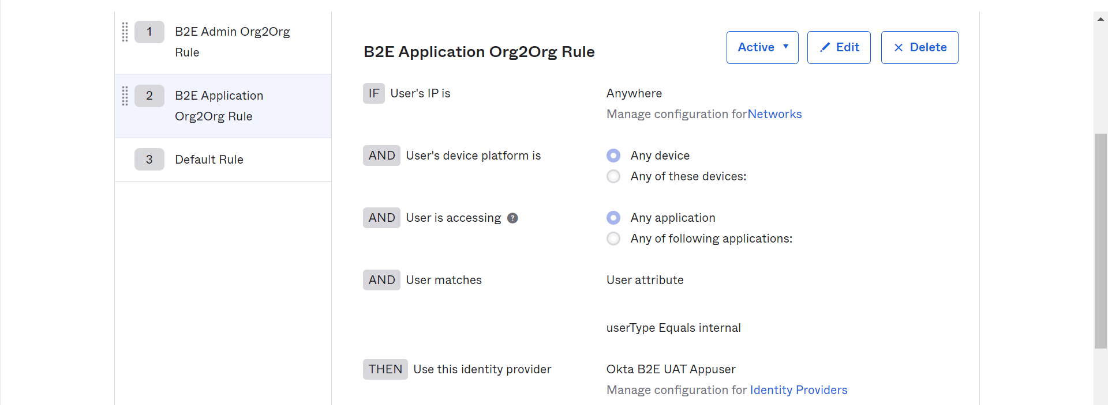

## API

### Authorization Server

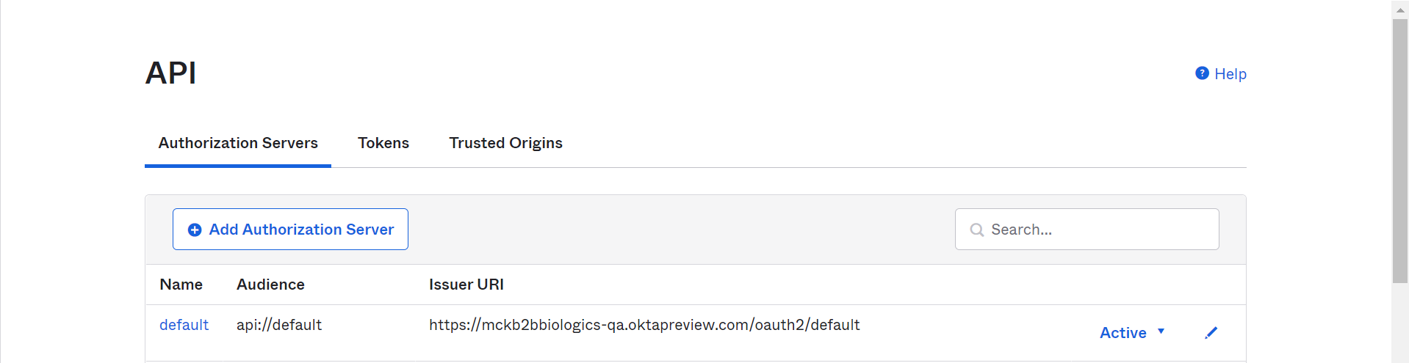

#### Default

##### Settings

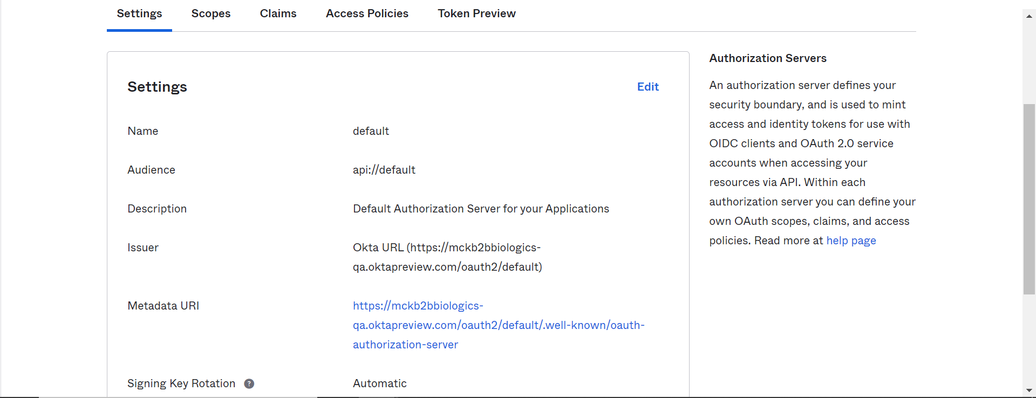



##### Claims

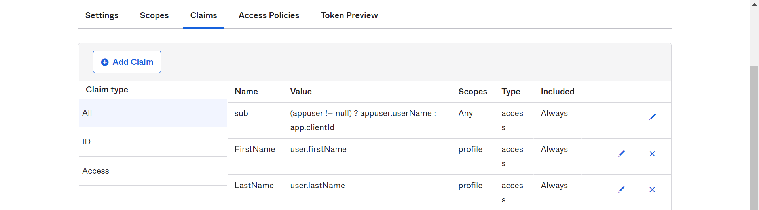

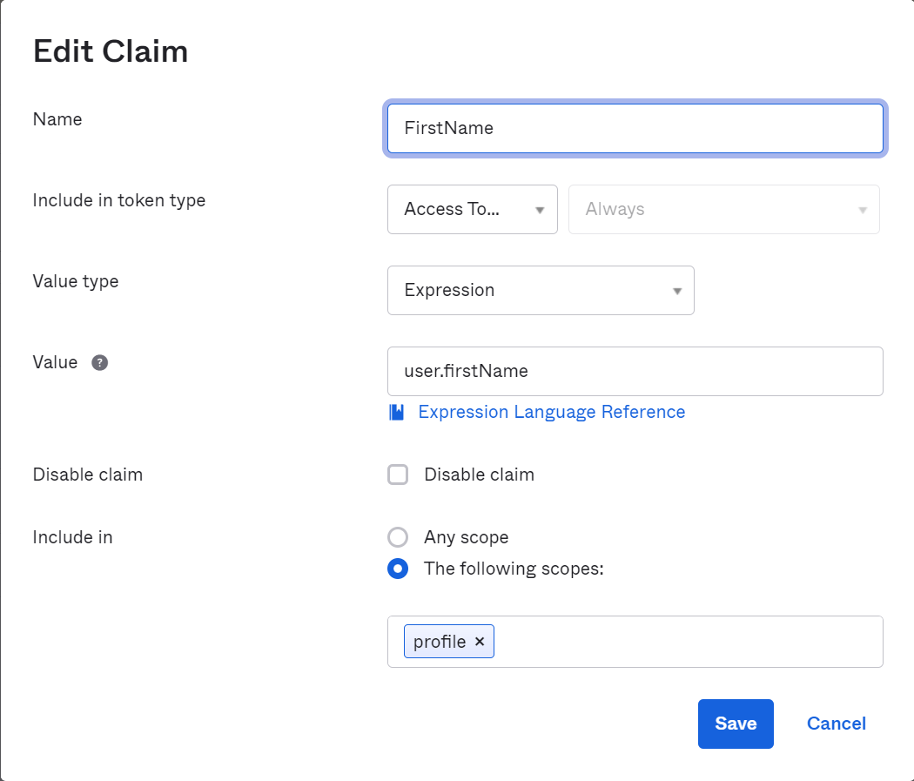

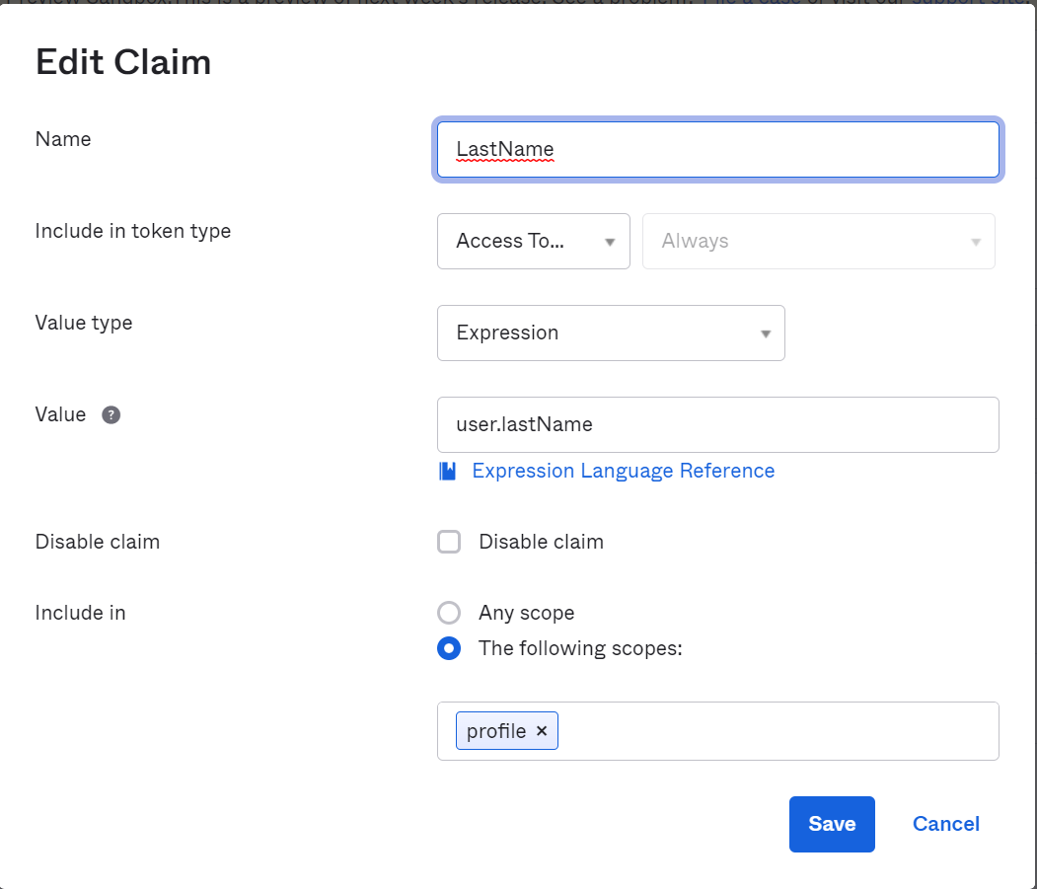

##### Access Policies

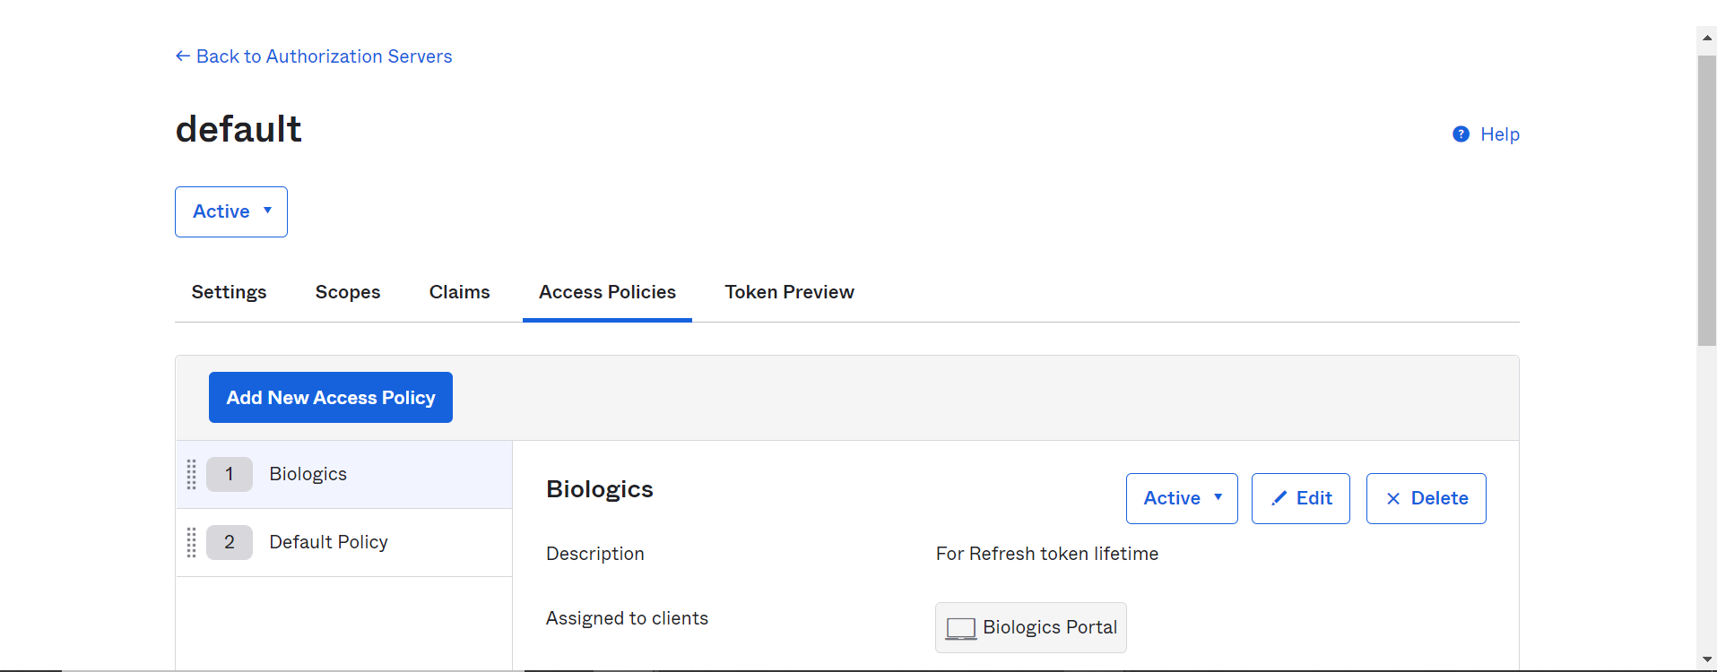



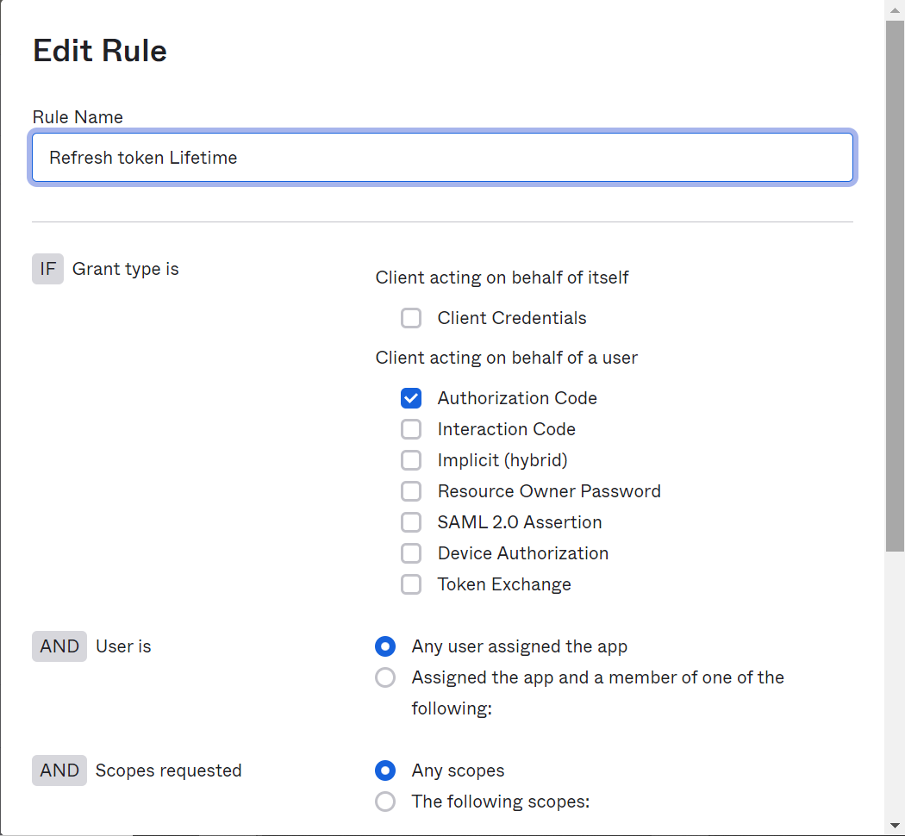

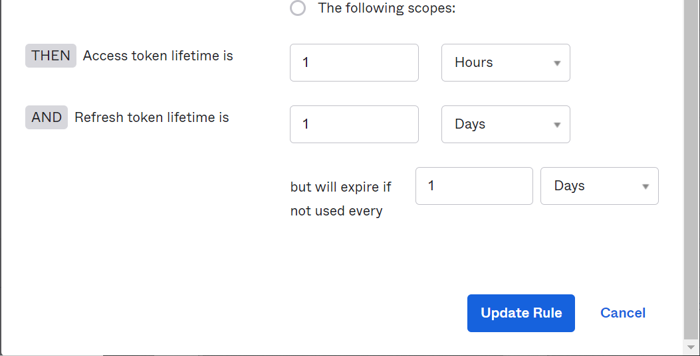

##### Tokens

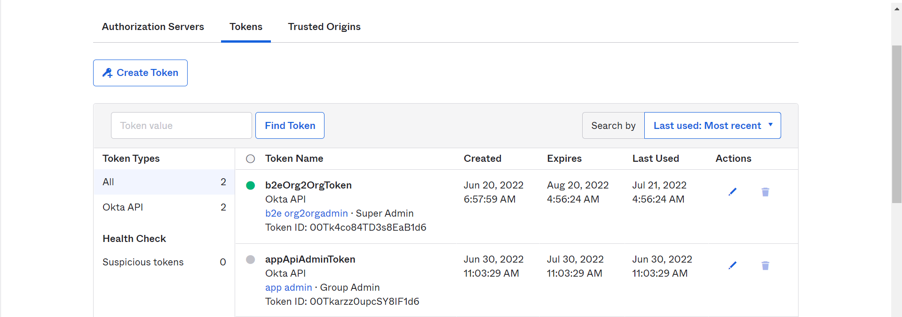

##### Token Preview

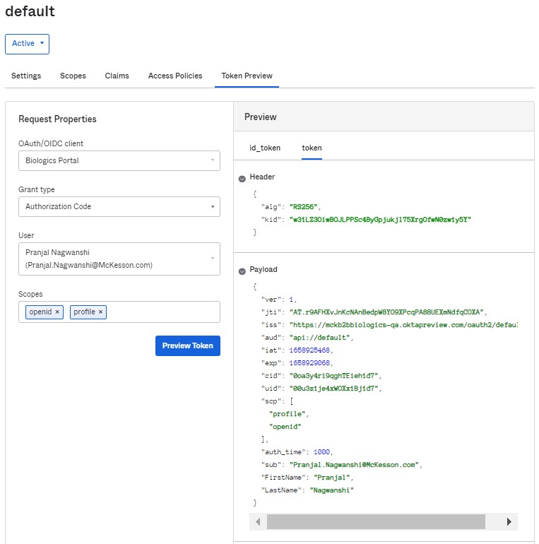

### Trusted Origins

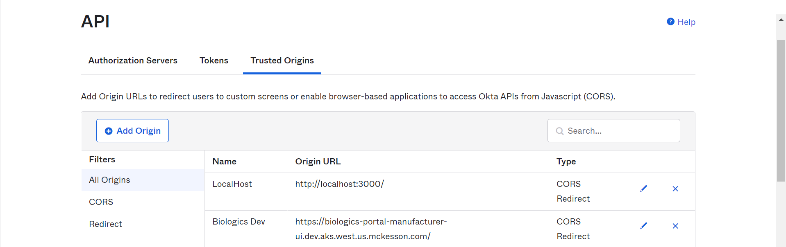

# Functional Diagram & Flow

## Flow Diagram



Figure 2 : Logical View for Biologics Portal

## Process Flows

|  |  |
| --- | --- |
| **Steps#** | **Description** |
| 1 | User will try to access portal URL in browser through internet. |
| 2 | Portal is ReactJS based application and will be integrated with Okta using OIDC PKCE integration flow. Portal will send authentication request to Okta OIDC endpoint. |
| 3 | User will be prompted to enter user login details on Okta login page. |
| 4 | Routing rules will be configured on Okta for IDP discovery |
| * 1. Based on routing rule, internal users will be redirected to Okta B2E for authentication |
| * 1. External users will be authenticated locally with Okta B2B directory |
| 5 | Users will be prompted to enter login password. |
| * 1. Okta B2E will validate internal user login credential and applicable MFA. |
| * 1. Okta B2B will validate external user login credential and applicable MFA. |
| 6 | In case of internal user, Okta B2E will send authentication response to Okta B2E through SAML assertion. Okta B2B will validate SAML assertion with pre-loaded internal users accounts. |
| 7 | Okta B2B will generates access token, ID token and refresh token and will send them to portal. |
| 8 | Portal will authorize user based on OIDC claims and user details available in portal’s config DB and user will get access to portal dashboard. |

# Logging

## System Logs

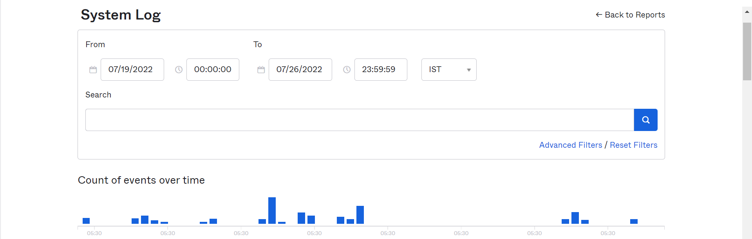

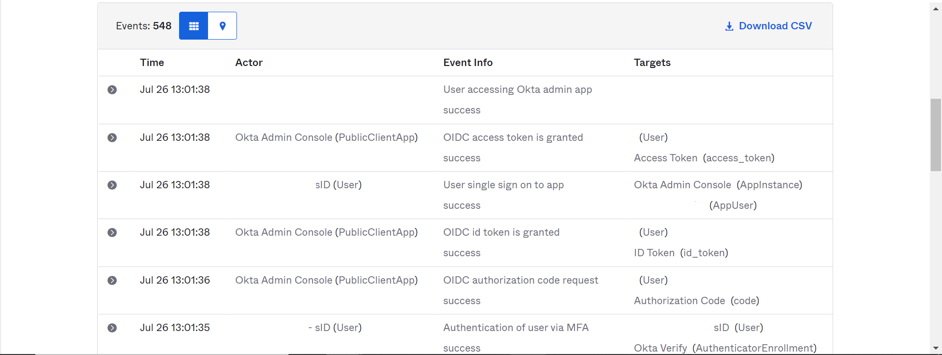

# Test Login

External user

Invitation code is handled by Application team

After you click on log in page

Internal User

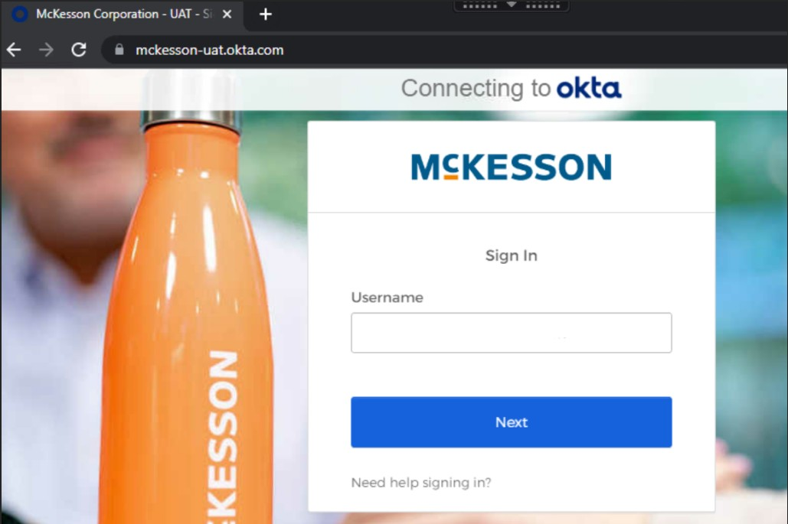

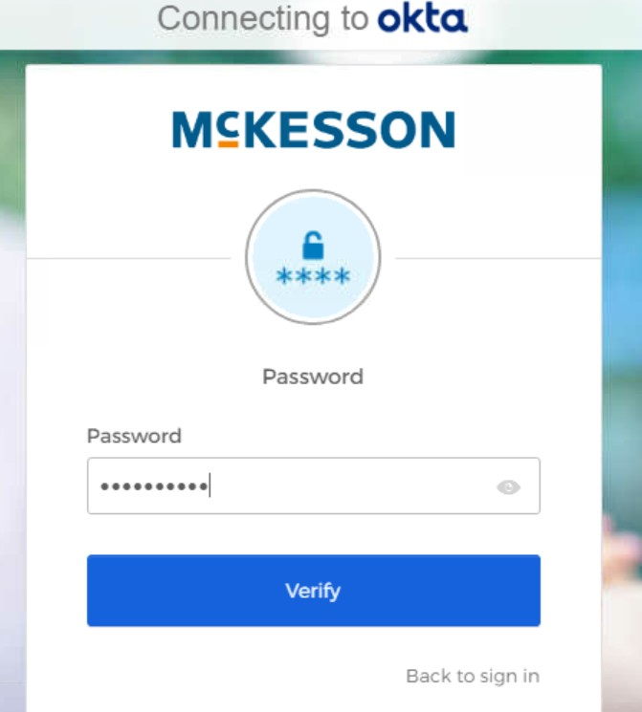

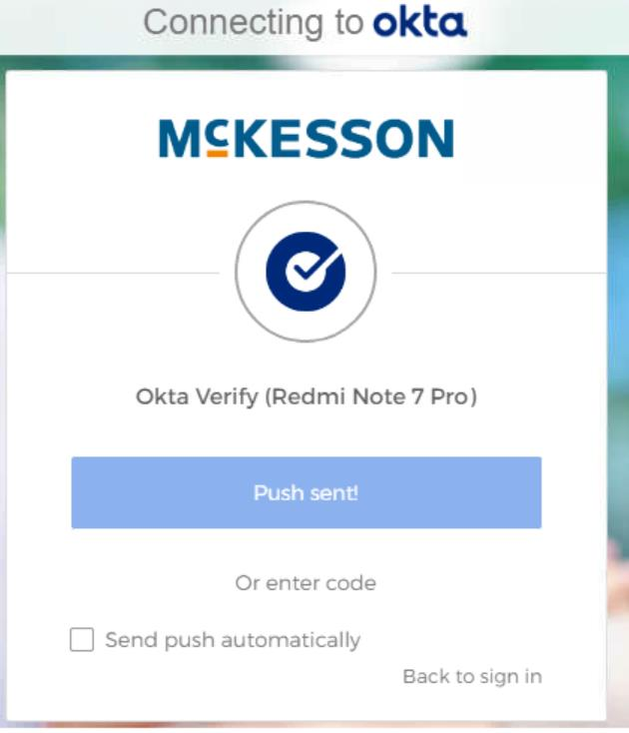

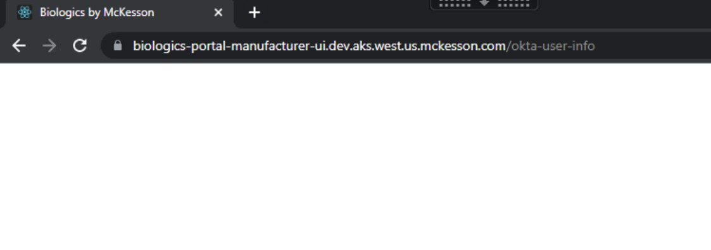

# Common Error/Issues:

1. Due to the old cache or cookies below error page appears sometimes. In this case, user need to try in a new browser session or by clearing the cache/cookies.  
     
   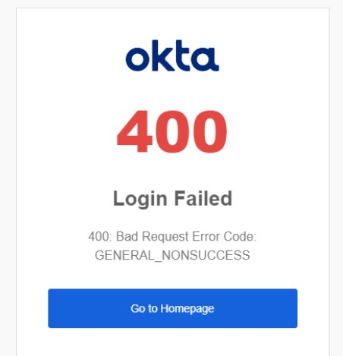
2. If a user doesn’t have access to the application.

